Test Case: tc001_SPX_Dev5_Validar_Campos_Proceso_Nuevo_Articulos_Almacen
Step 1 - Enter username and password and click to button Enter : Credentials Entered
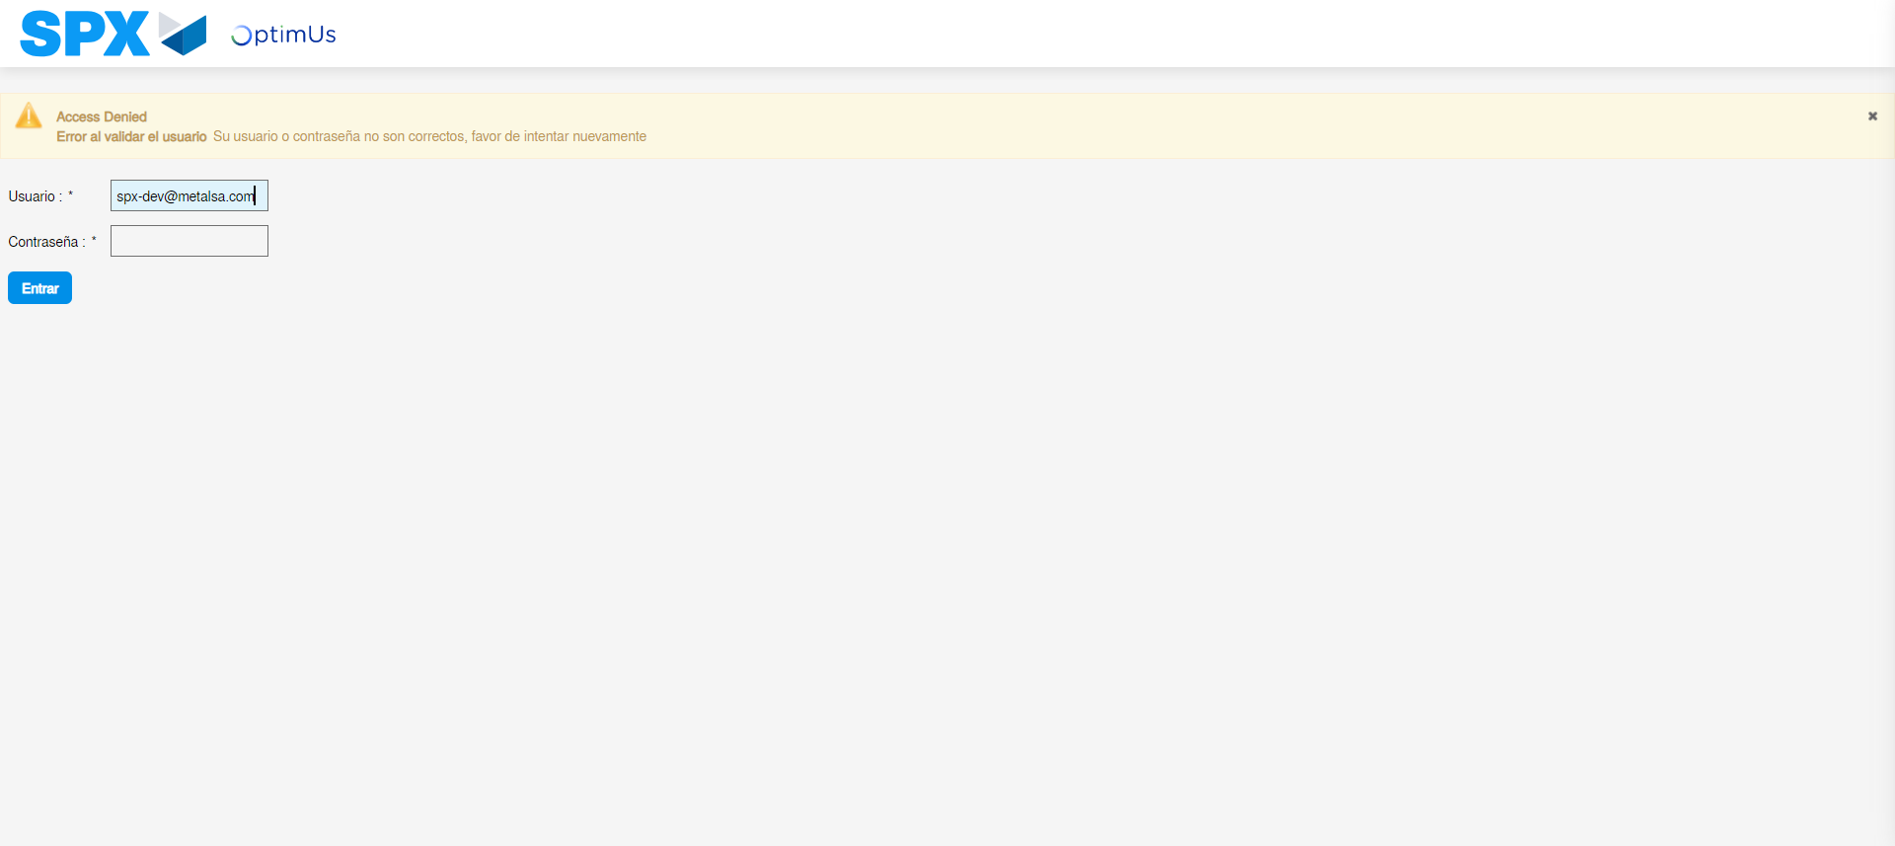Image file-name: QC_Testing-tc001_SPX_Dev5_Validar_Campos_Proceso_Nuevo_Articulos_Almacen-may. 17 2024, 02 17 11 p. m.

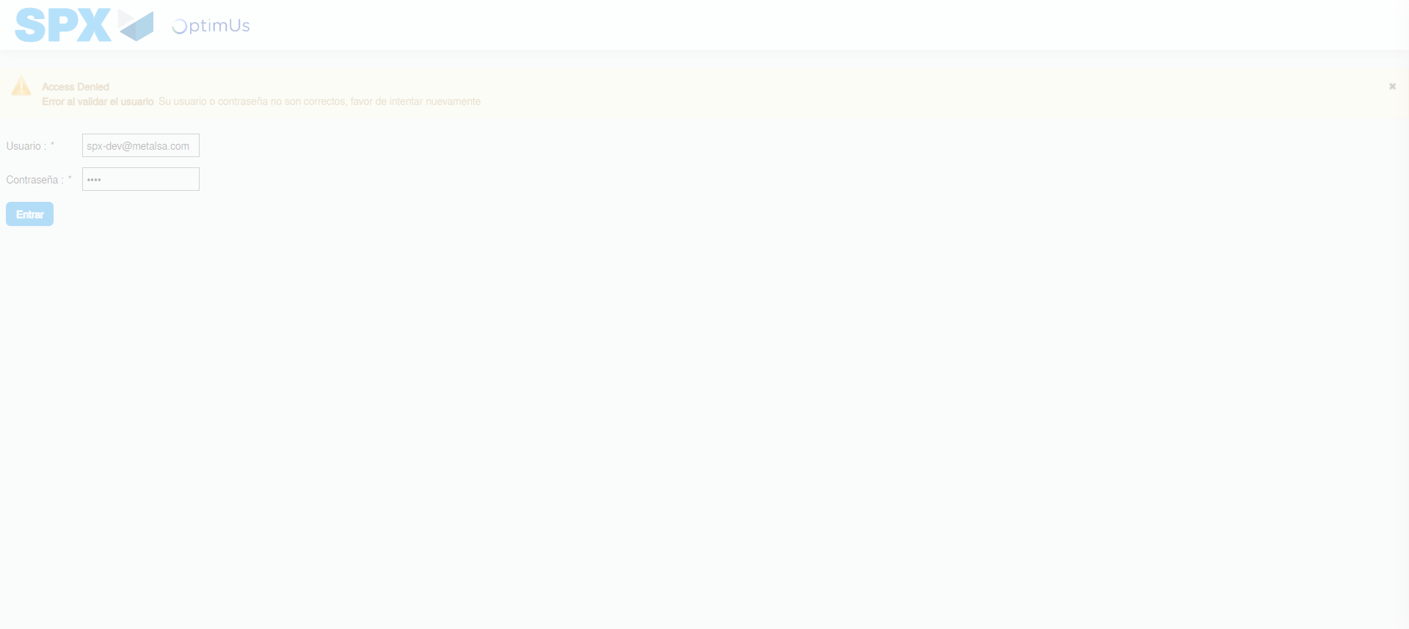Image file-name: QC_Testing-tc001_SPX_Dev5_Validar_Campos_Proceso_Nuevo_Articulos_Almacen-may. 17 2024, 02 17 12 p. m.

Image file-name: QC_Testing-tc001_SPX_Dev5_Validar_Campos_Proceso_Nuevo_Articulos_Almacen-may. 17 2024, 02 17 13 p. m.

Step 2 - Select to UEN and Access to Articulos por Procesar: UEN Correctly selected and Correct access
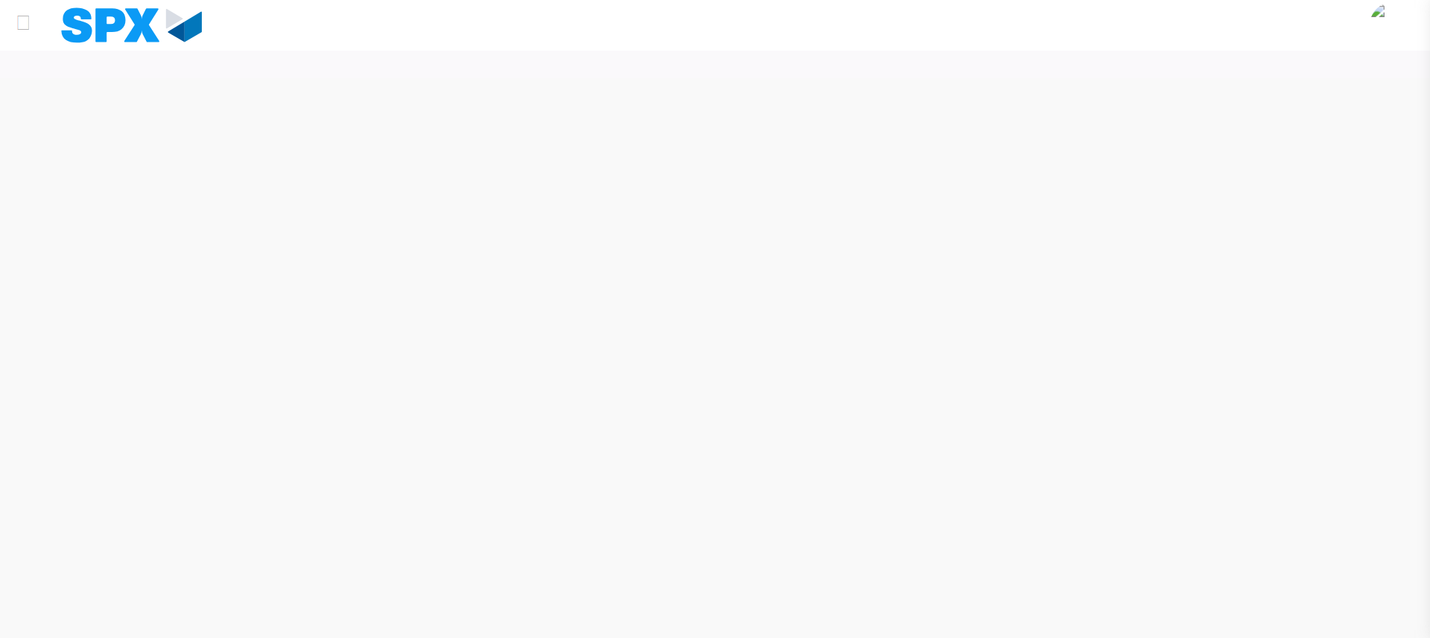Image file-name: QC_Testing-tc001_SPX_Dev5_Validar_Campos_Proceso_Nuevo_Articulos_Almacen-may. 17 2024, 02 17 18 p. m.

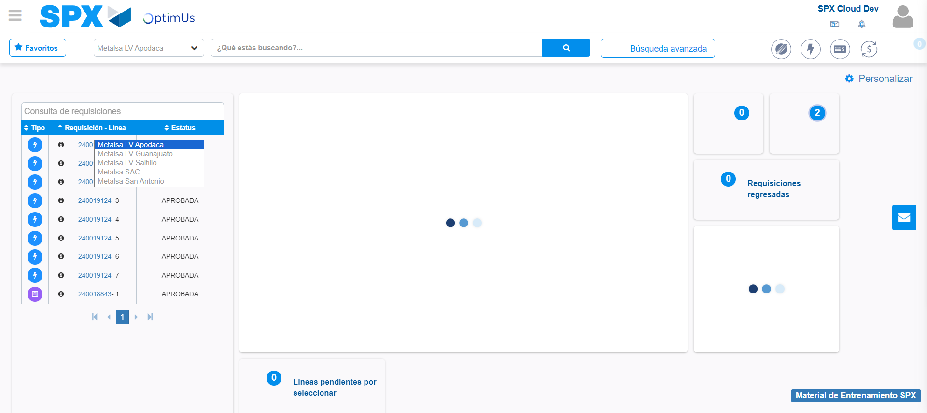Image file-name: QC_Testing-tc001_SPX_Dev5_Validar_Campos_Proceso_Nuevo_Articulos_Almacen-may. 17 2024, 02 17 19 p. m.

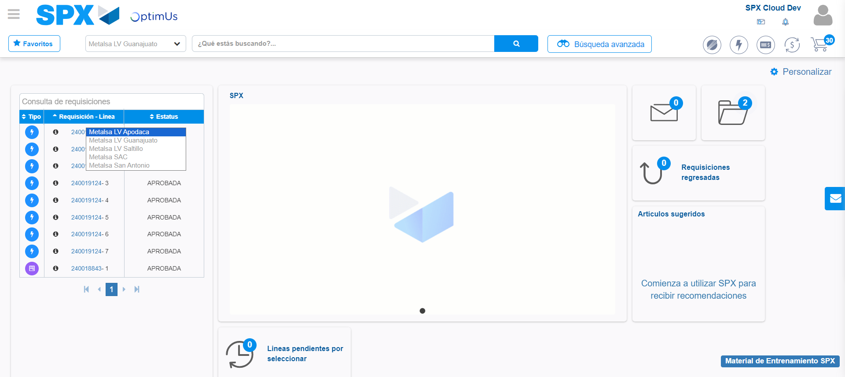Image file-name: QC_Testing-tc001_SPX_Dev5_Validar_Campos_Proceso_Nuevo_Articulos_Almacen-may. 17 2024, 02 17 20 p. m.

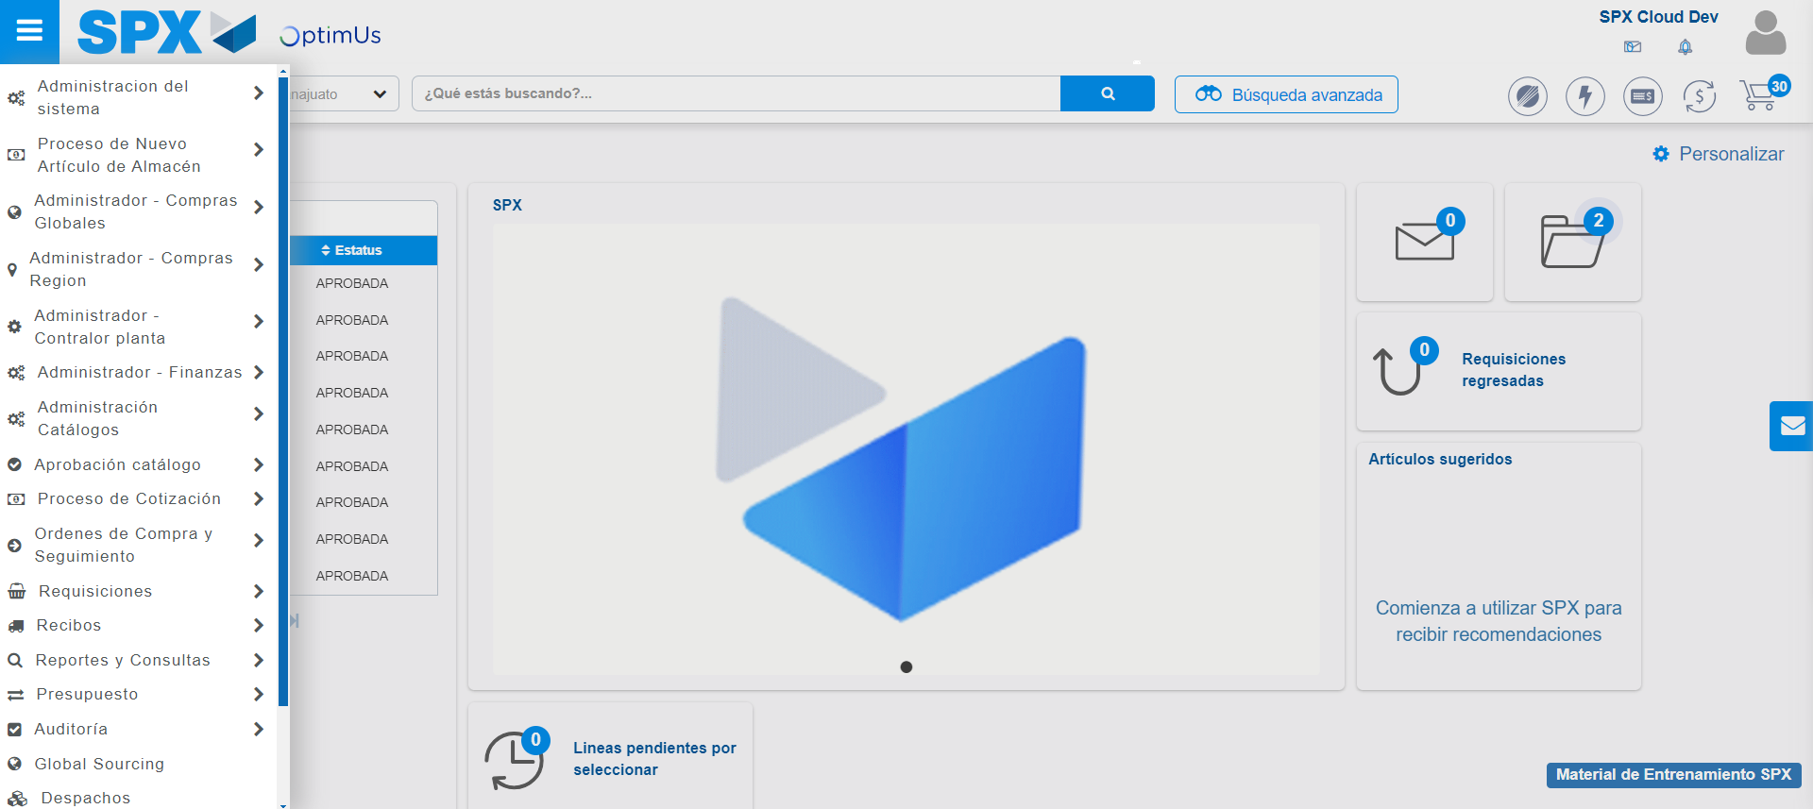Image file-name: QC_Testing-tc001_SPX_Dev5_Validar_Campos_Proceso_Nuevo_Articulos_Almacen-may. 17 2024, 02 17 21 p. m.

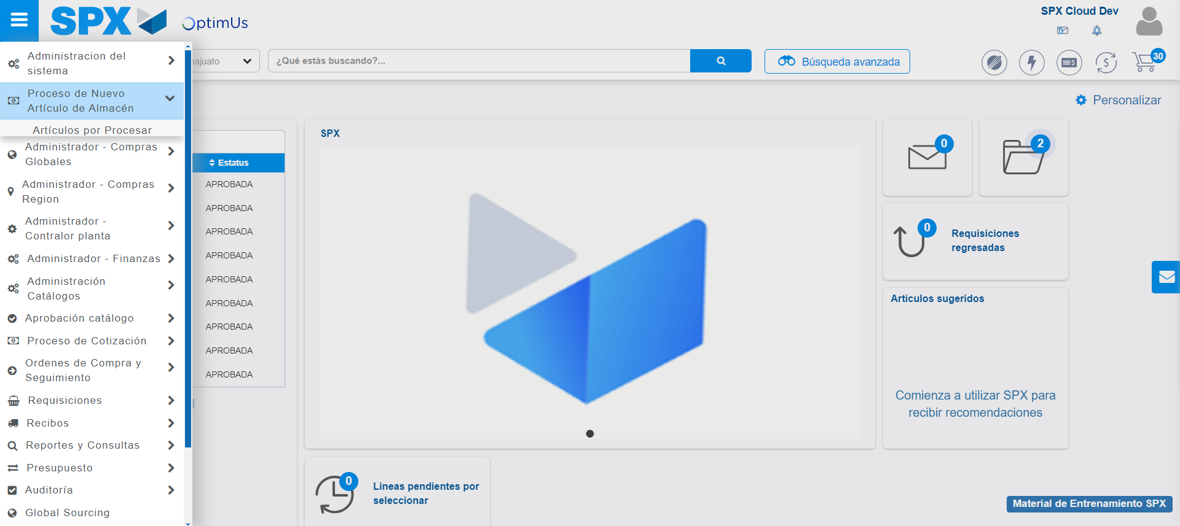Image file-name: QC_Testing-tc001_SPX_Dev5_Validar_Campos_Proceso_Nuevo_Articulos_Almacen-may. 17 2024, 02 17 22 p. m.

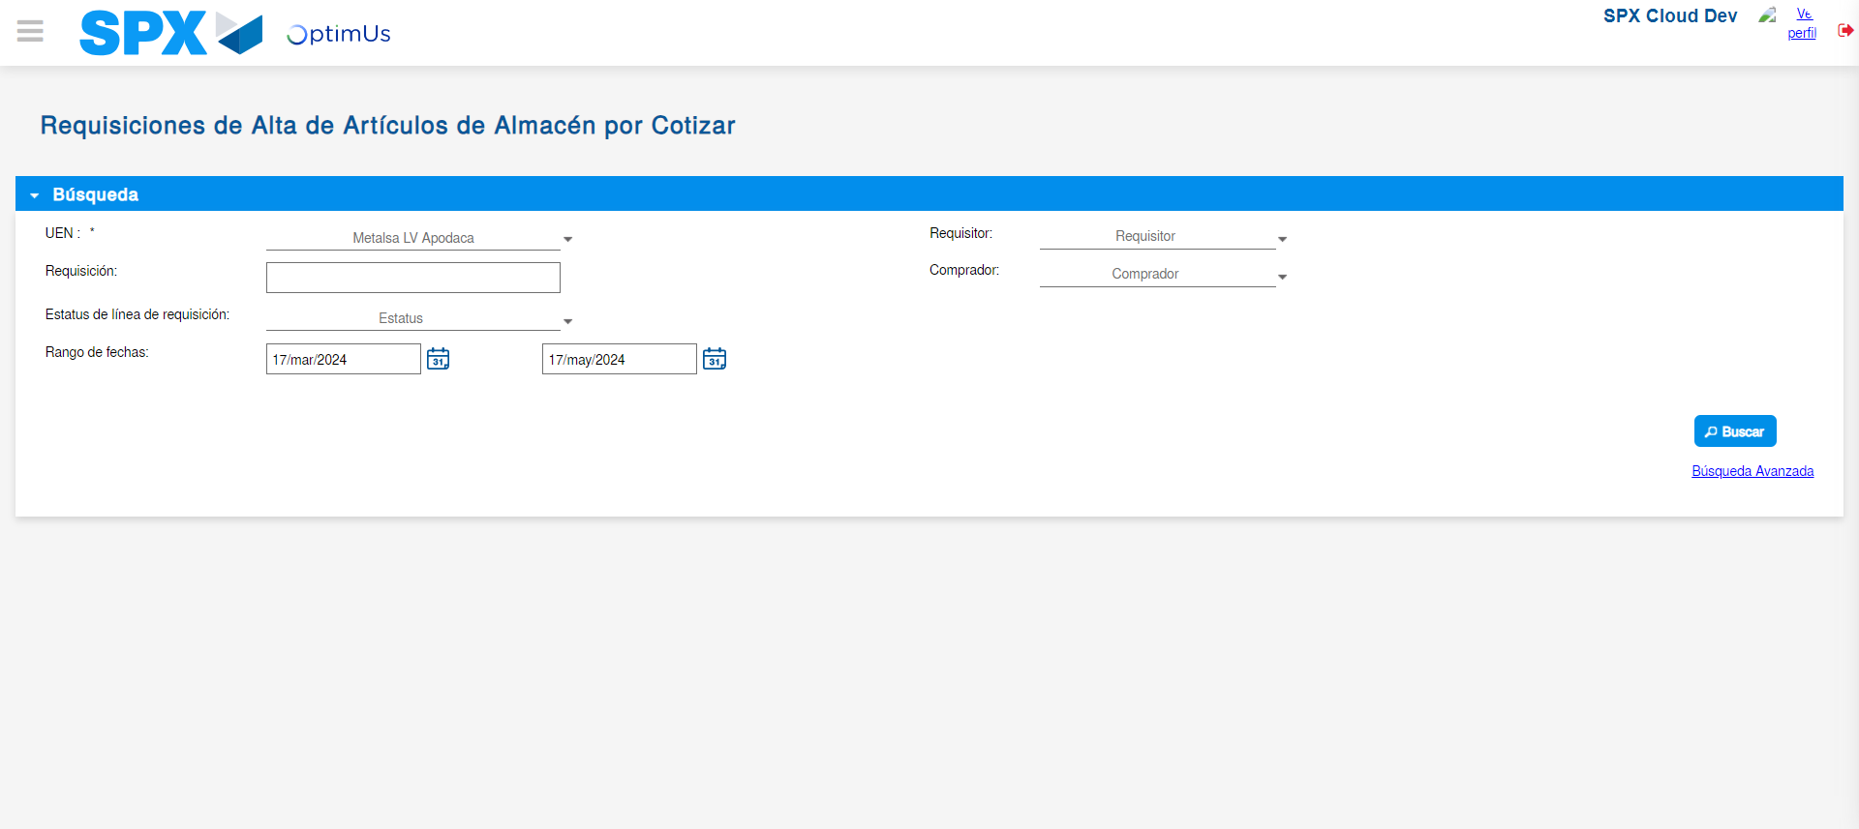Image file-name: QC_Testing-tc001_SPX_Dev5_Validar_Campos_Proceso_Nuevo_Articulos_Almacen-may. 17 2024, 02 17 26 p. m.

Step 3 - Validate search fields: Validated fields
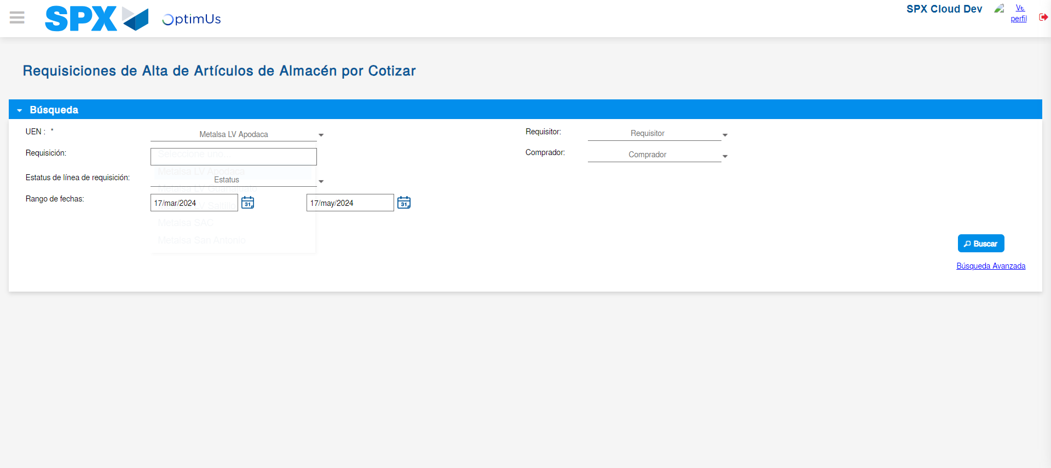Image file-name: QC_Testing-tc001_SPX_Dev5_Validar_Campos_Proceso_Nuevo_Articulos_Almacen-may. 17 2024, 02 17 27 p. m.

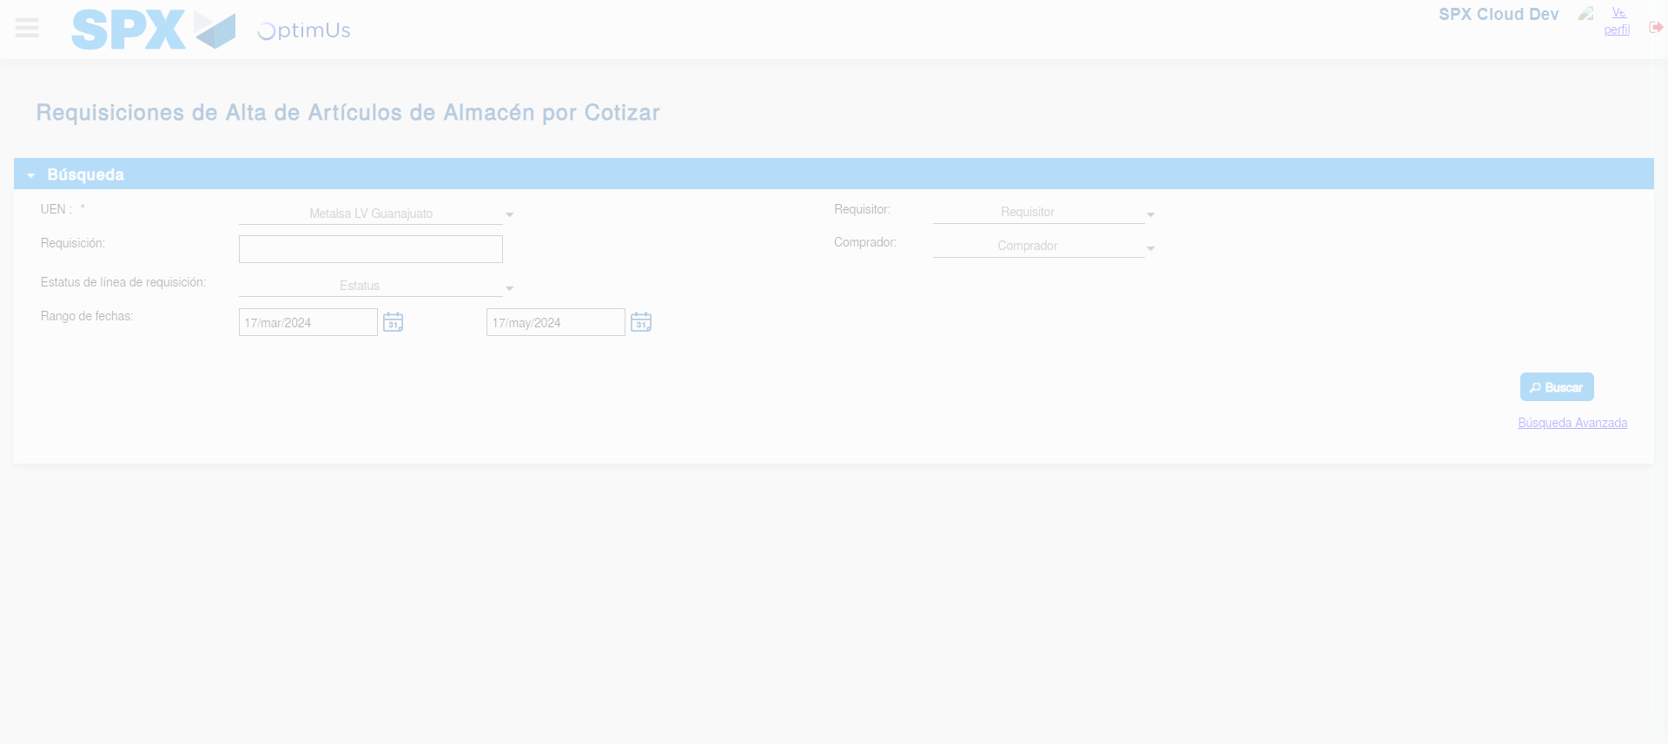Image file-name: QC_Testing-tc001_SPX_Dev5_Validar_Campos_Proceso_Nuevo_Articulos_Almacen-may. 17 2024, 02 17 28 p. m.

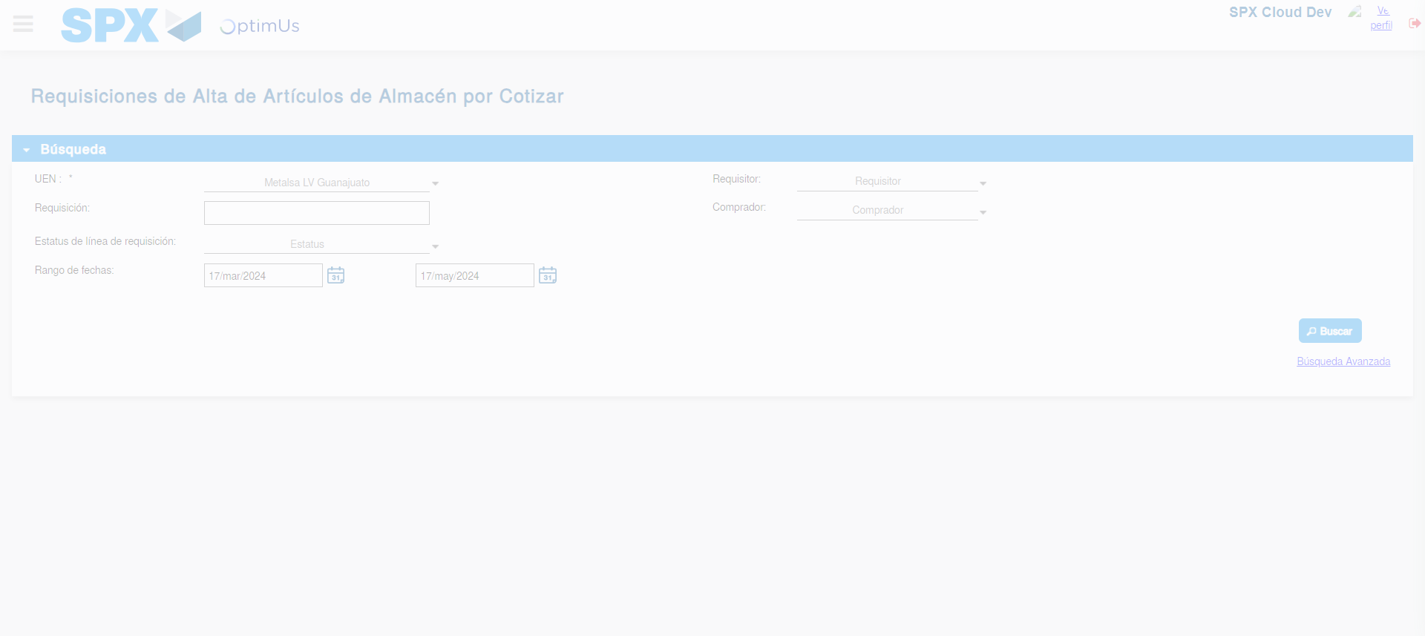Image file-name: QC_Testing-tc001_SPX_Dev5_Validar_Campos_Proceso_Nuevo_Articulos_Almacen-may. 17 2024, 02 17 31 p. m.

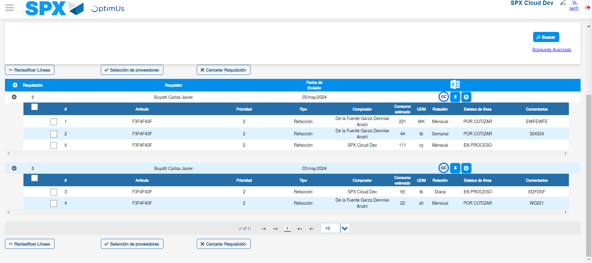Image file-name: QC_Testing-tc001_SPX_Dev5_Validar_Campos_Proceso_Nuevo_Articulos_Almacen-may. 17 2024, 02 17 35 p. m.

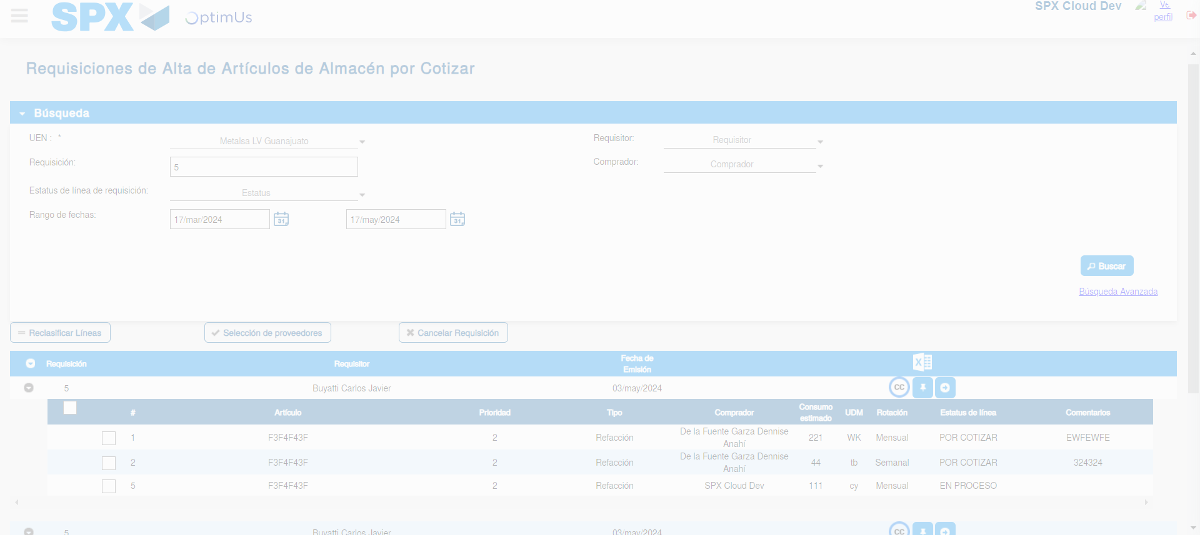Image file-name: QC_Testing-tc001_SPX_Dev5_Validar_Campos_Proceso_Nuevo_Articulos_Almacen-may. 17 2024, 02 17 36 p. m.

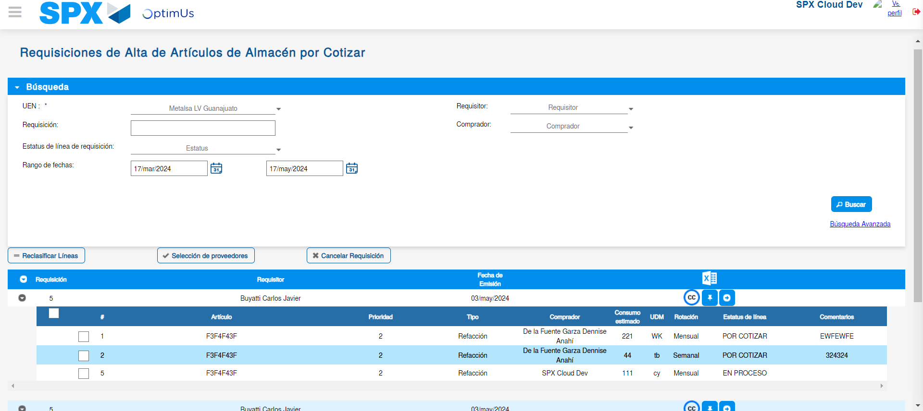Image file-name: QC_Testing-tc001_SPX_Dev5_Validar_Campos_Proceso_Nuevo_Articulos_Almacen-may. 17 2024, 02 17 40 p. m.

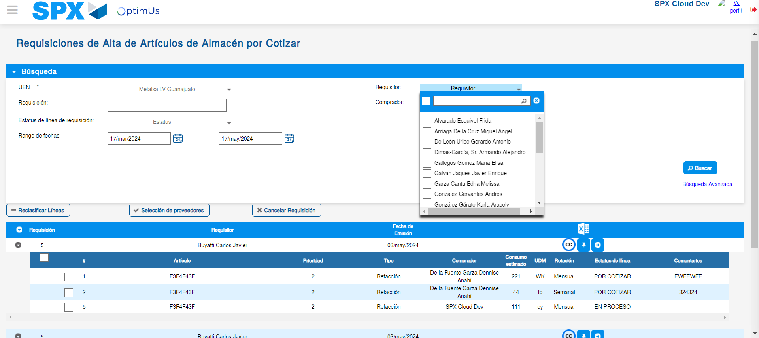Image file-name: QC_Testing-tc001_SPX_Dev5_Validar_Campos_Proceso_Nuevo_Articulos_Almacen-may. 17 2024, 02 17 41 p. m.

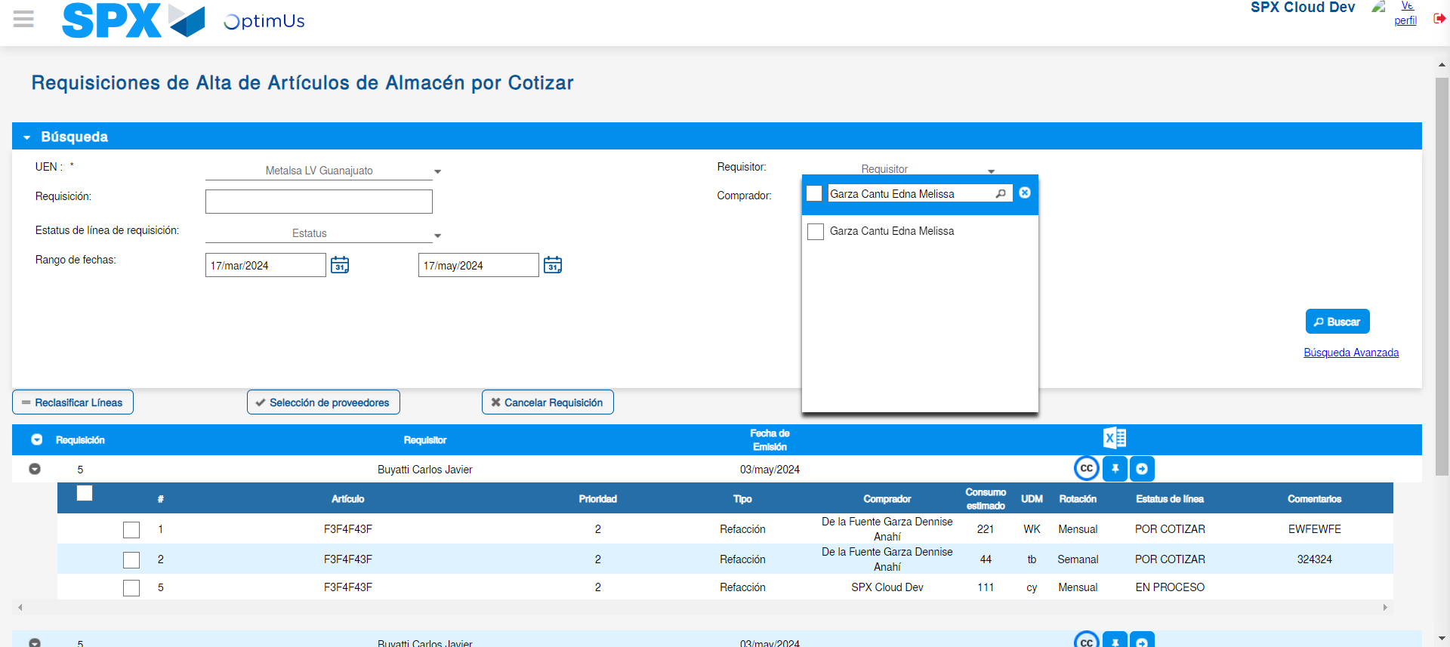Image file-name: QC_Testing-tc001_SPX_Dev5_Validar_Campos_Proceso_Nuevo_Articulos_Almacen-may. 17 2024, 02 17 42 p. m.

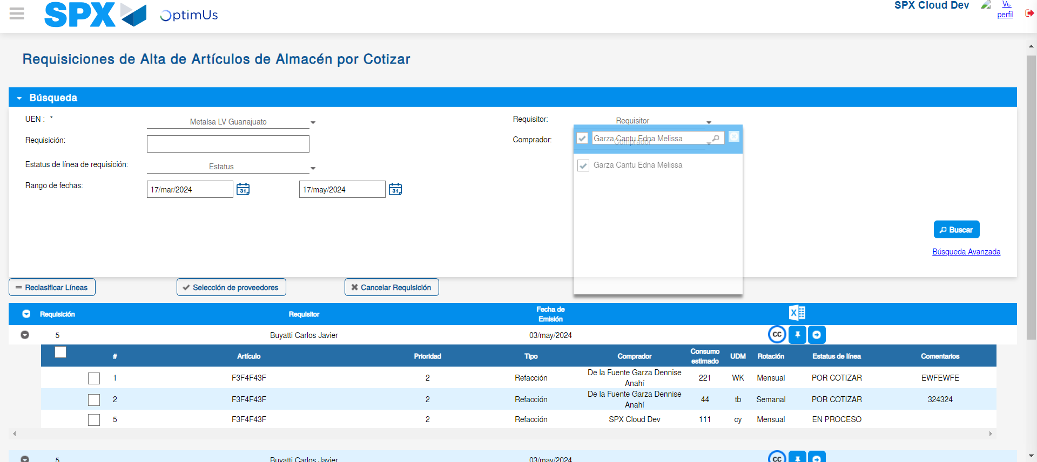Image file-name: QC_Testing-tc001_SPX_Dev5_Validar_Campos_Proceso_Nuevo_Articulos_Almacen-may. 17 2024, 02 17 43 p. m.

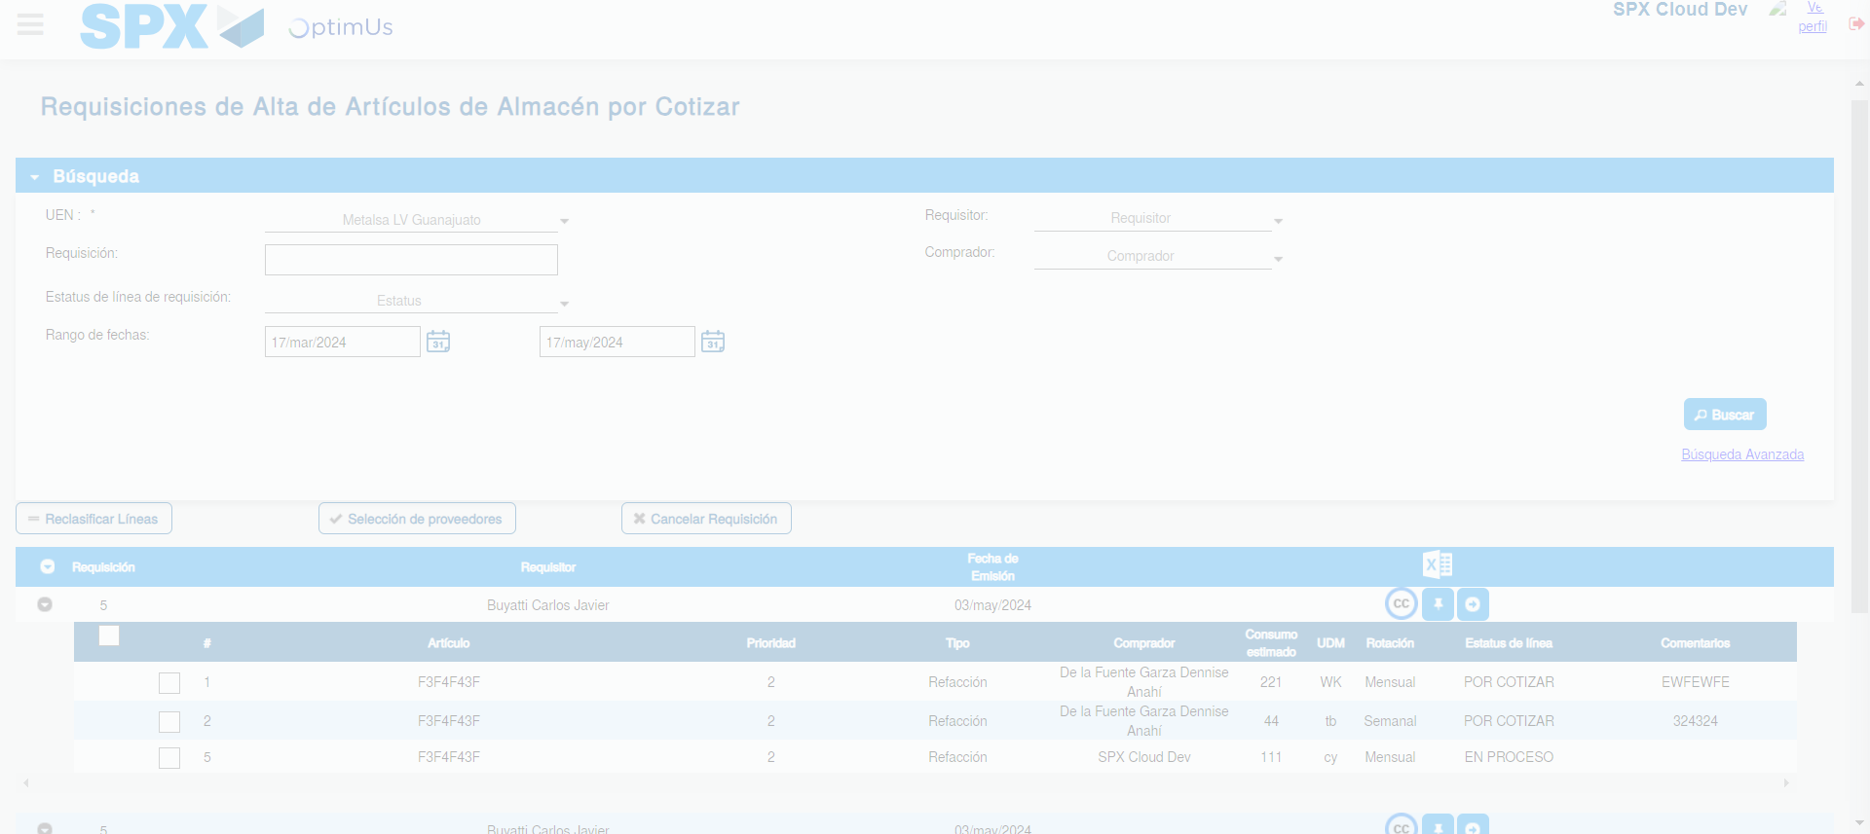Image file-name: QC_Testing-tc001_SPX_Dev5_Validar_Campos_Proceso_Nuevo_Articulos_Almacen-may. 17 2024, 02 17 46 p. m.

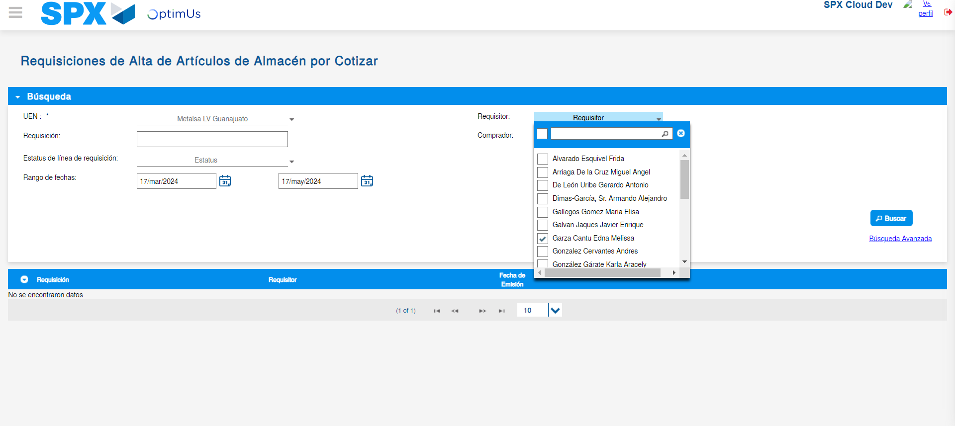Image file-name: QC_Testing-tc001_SPX_Dev5_Validar_Campos_Proceso_Nuevo_Articulos_Almacen-may. 17 2024, 02 17 50 p. m.

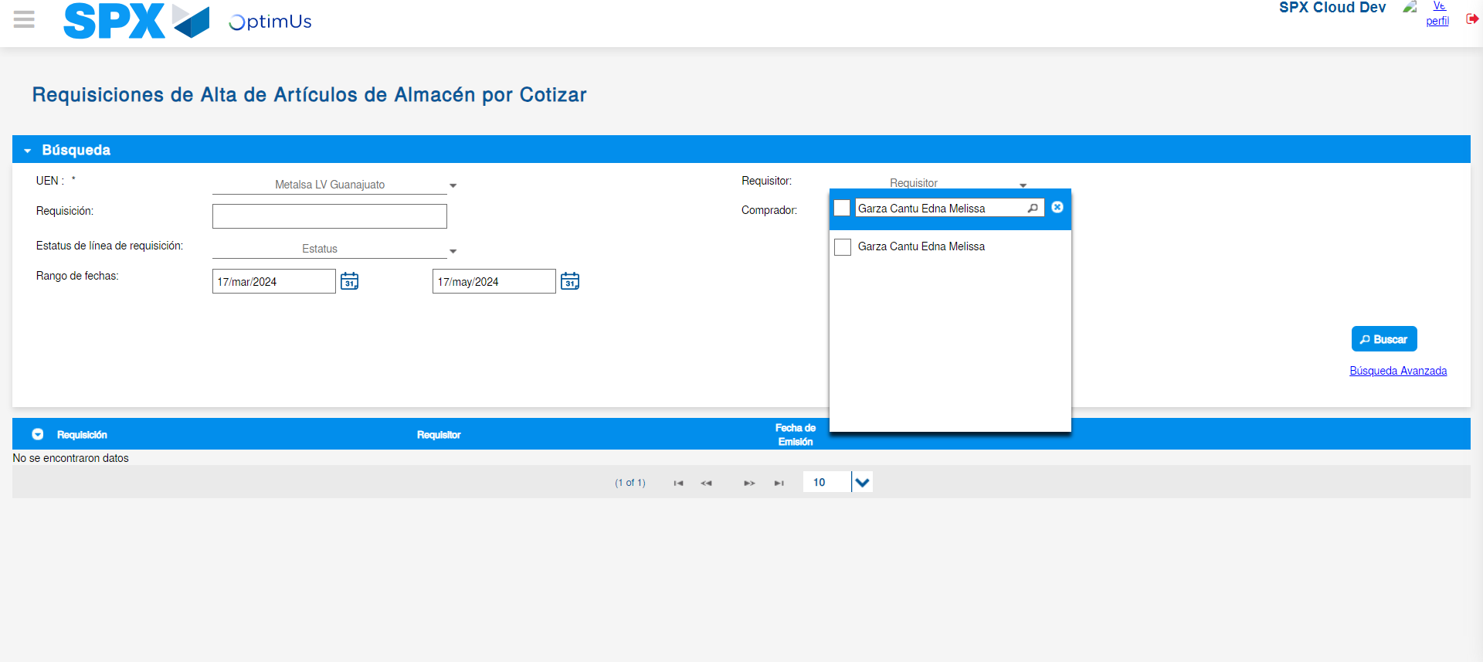Image file-name: QC_Testing-tc001_SPX_Dev5_Validar_Campos_Proceso_Nuevo_Articulos_Almacen-may. 17 2024, 02 17 51 p. m.

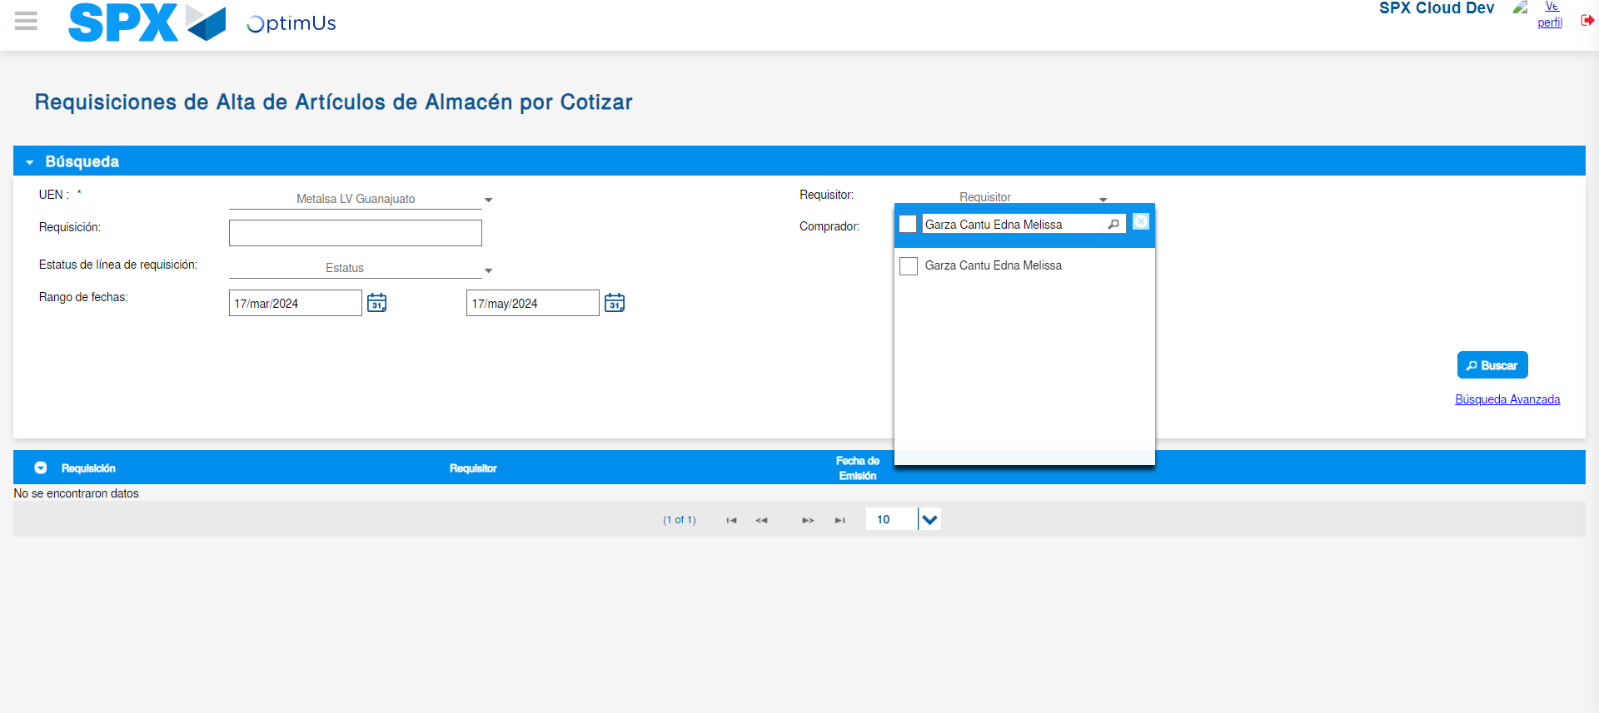Image file-name: QC_Testing-tc001_SPX_Dev5_Validar_Campos_Proceso_Nuevo_Articulos_Almacen-may. 17 2024, 02 17 52 p. m.

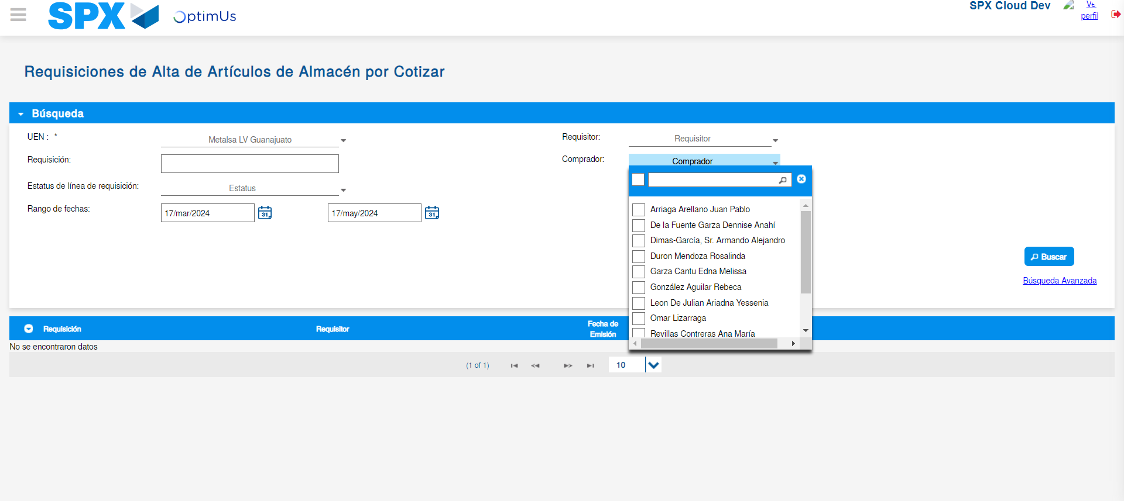Image file-name: QC_Testing-tc001_SPX_Dev5_Validar_Campos_Proceso_Nuevo_Articulos_Almacen-may. 17 2024, 02 17 55 p. m.

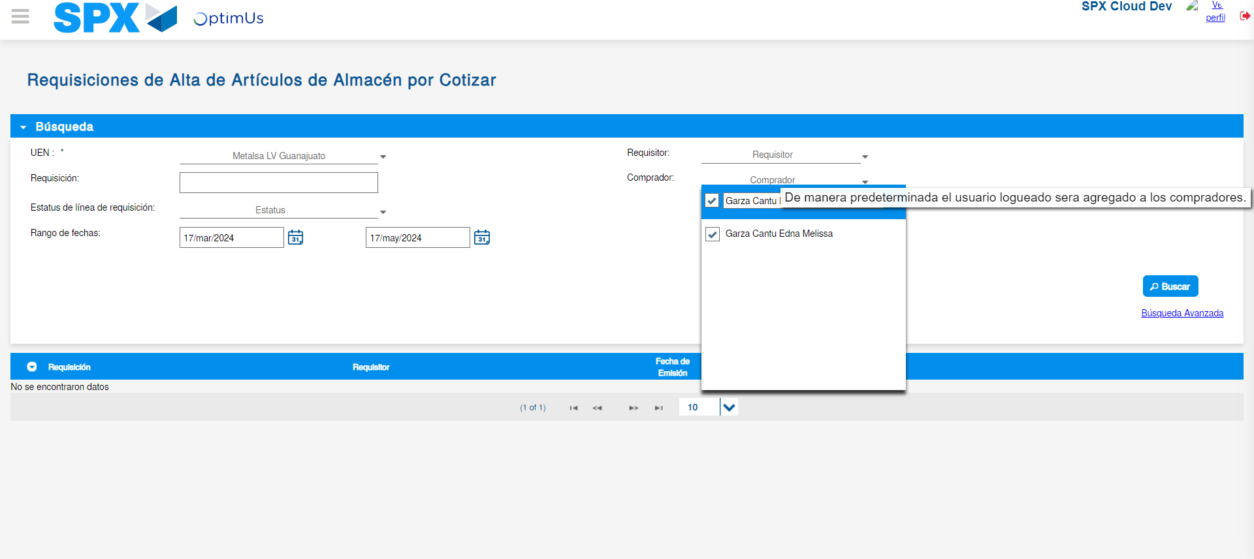Image file-name: QC_Testing-tc001_SPX_Dev5_Validar_Campos_Proceso_Nuevo_Articulos_Almacen-may. 17 2024, 02 17 56 p. m.

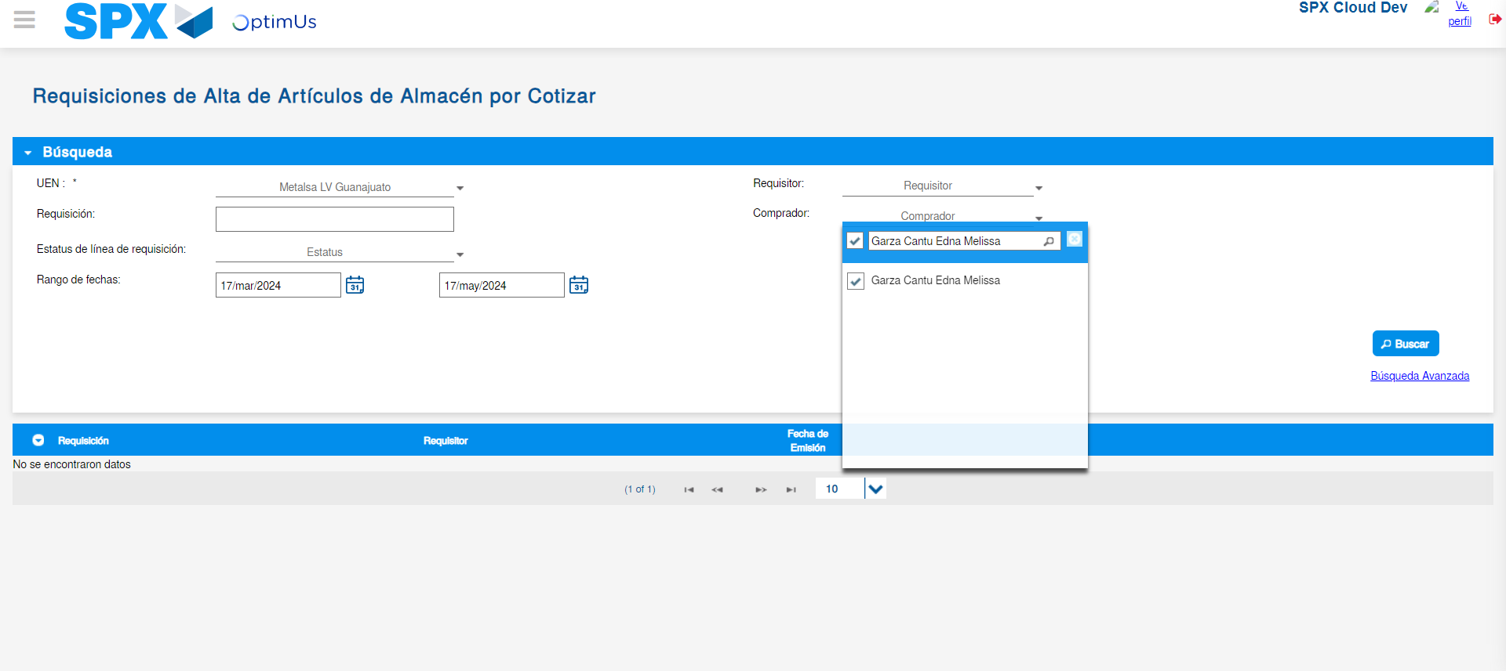Image file-name: QC_Testing-tc001_SPX_Dev5_Validar_Campos_Proceso_Nuevo_Articulos_Almacen-may. 17 2024, 02 17 57 p. m.

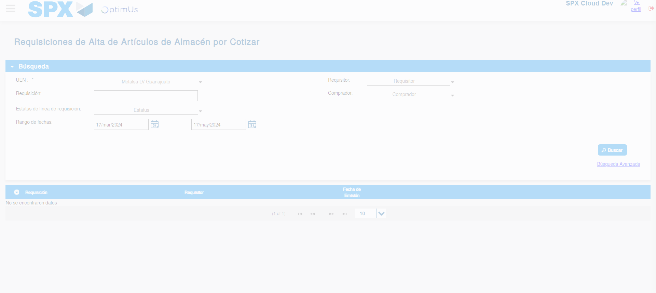Image file-name: QC_Testing-tc001_SPX_Dev5_Validar_Campos_Proceso_Nuevo_Articulos_Almacen-may. 17 2024, 02 18 00 p. m.

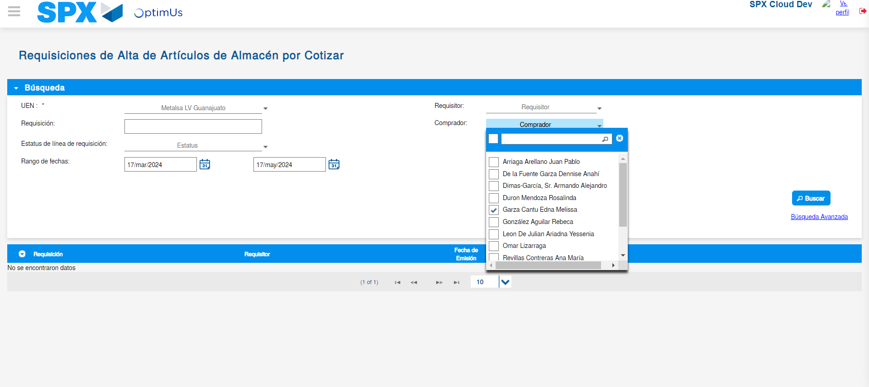Image file-name: QC_Testing-tc001_SPX_Dev5_Validar_Campos_Proceso_Nuevo_Articulos_Almacen-may. 17 2024, 02 18 04 p. m.

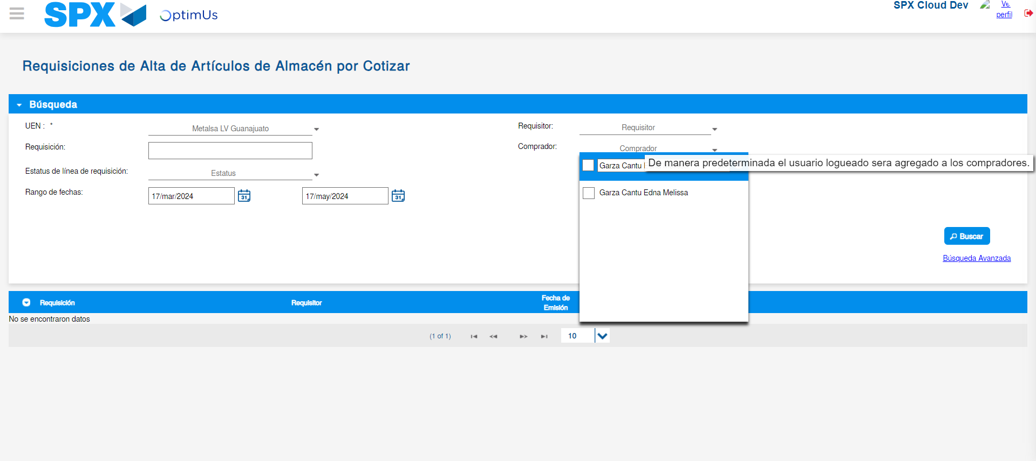Image file-name: QC_Testing-tc001_SPX_Dev5_Validar_Campos_Proceso_Nuevo_Articulos_Almacen-may. 17 2024, 02 18 05 p. m.

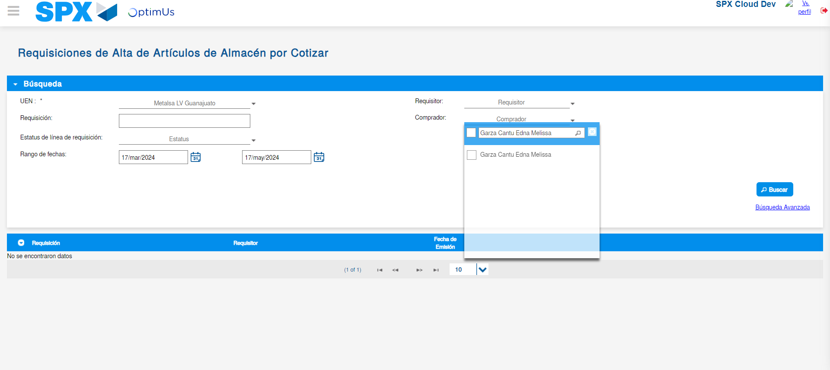Image file-name: QC_Testing-tc001_SPX_Dev5_Validar_Campos_Proceso_Nuevo_Articulos_Almacen-may. 17 2024, 02 18 06 p. m.

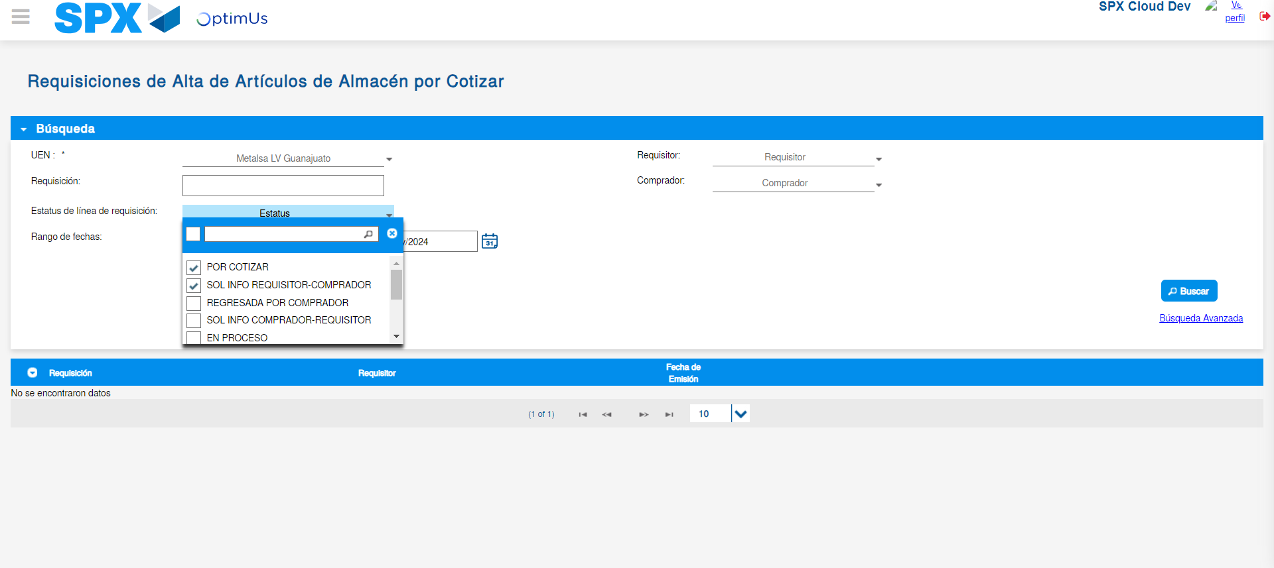Image file-name: QC_Testing-tc001_SPX_Dev5_Validar_Campos_Proceso_Nuevo_Articulos_Almacen-may. 17 2024, 02 18 09 p. m.

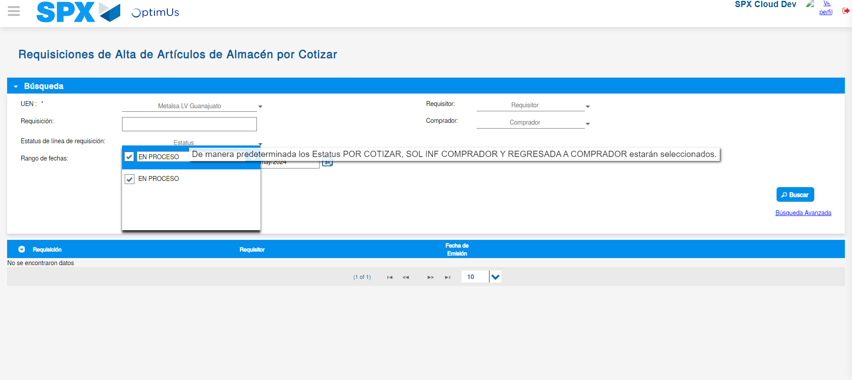Image file-name: QC_Testing-tc001_SPX_Dev5_Validar_Campos_Proceso_Nuevo_Articulos_Almacen-may. 17 2024, 02 18 10 p. m.

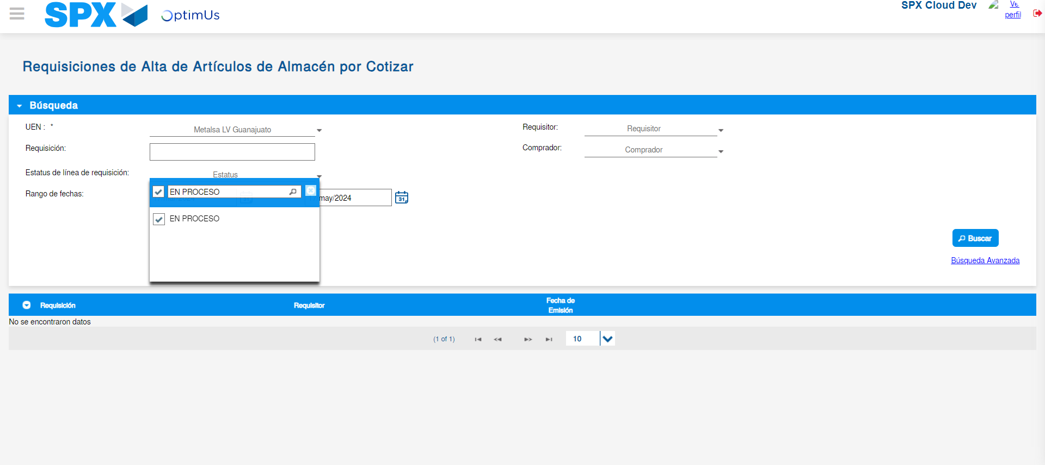Image file-name: QC_Testing-tc001_SPX_Dev5_Validar_Campos_Proceso_Nuevo_Articulos_Almacen-may. 17 2024, 02 18 11 p. m.

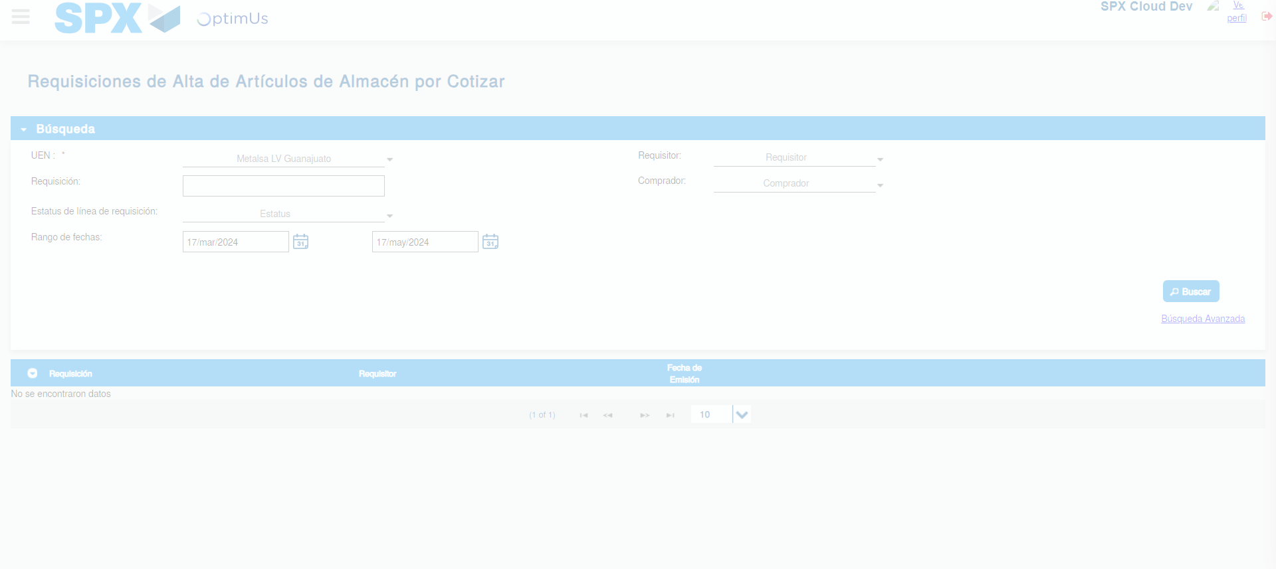Image file-name: QC_Testing-tc001_SPX_Dev5_Validar_Campos_Proceso_Nuevo_Articulos_Almacen-may. 17 2024, 02 18 15 p. m.

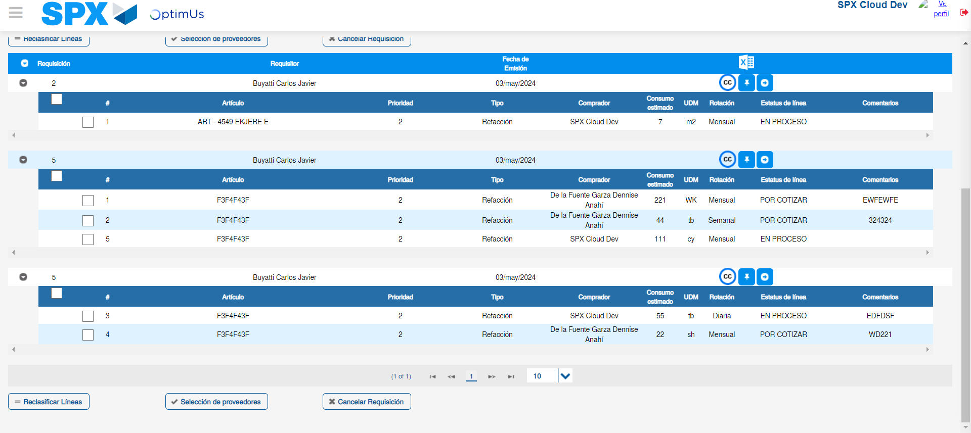Image file-name: QC_Testing-tc001_SPX_Dev5_Validar_Campos_Proceso_Nuevo_Articulos_Almacen-may. 17 2024, 02 18 18 p. m.

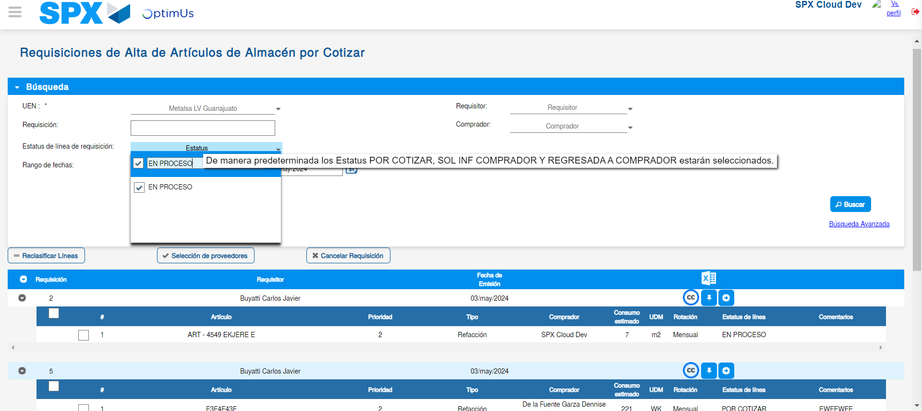Image file-name: QC_Testing-tc001_SPX_Dev5_Validar_Campos_Proceso_Nuevo_Articulos_Almacen-may. 17 2024, 02 18 19 p. m.

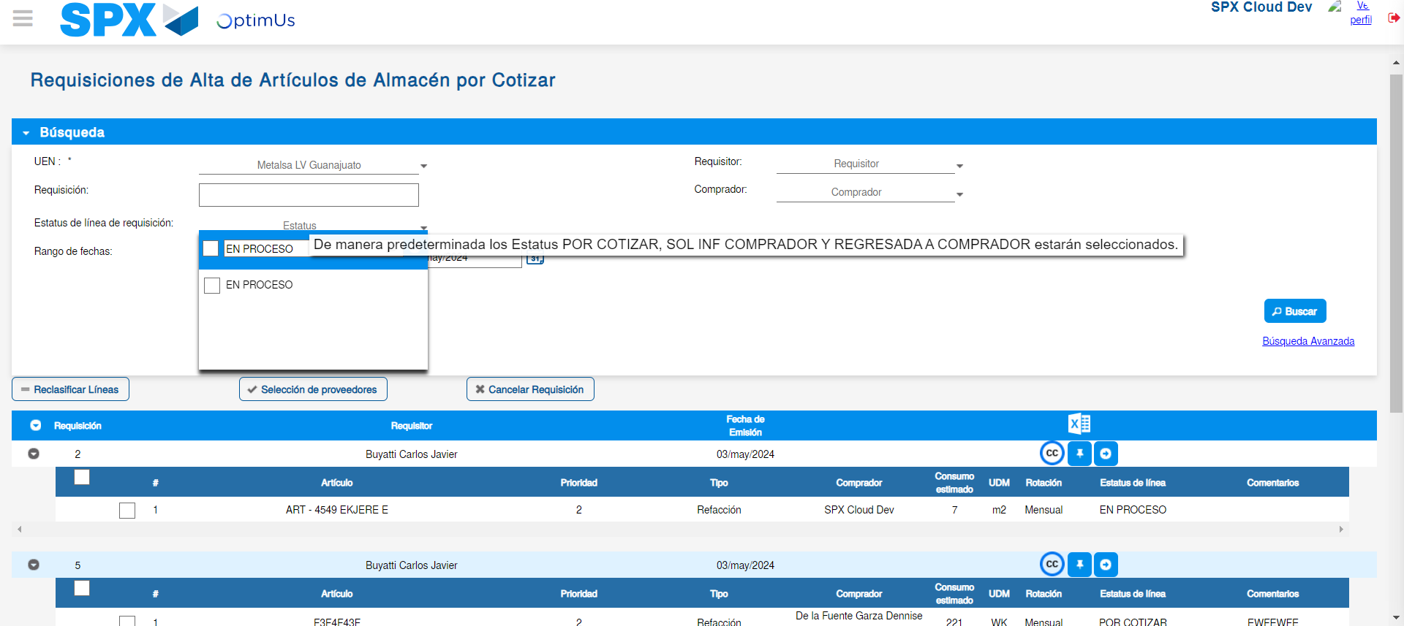Image file-name: QC_Testing-tc001_SPX_Dev5_Validar_Campos_Proceso_Nuevo_Articulos_Almacen-may. 17 2024, 02 18 20 p. m.

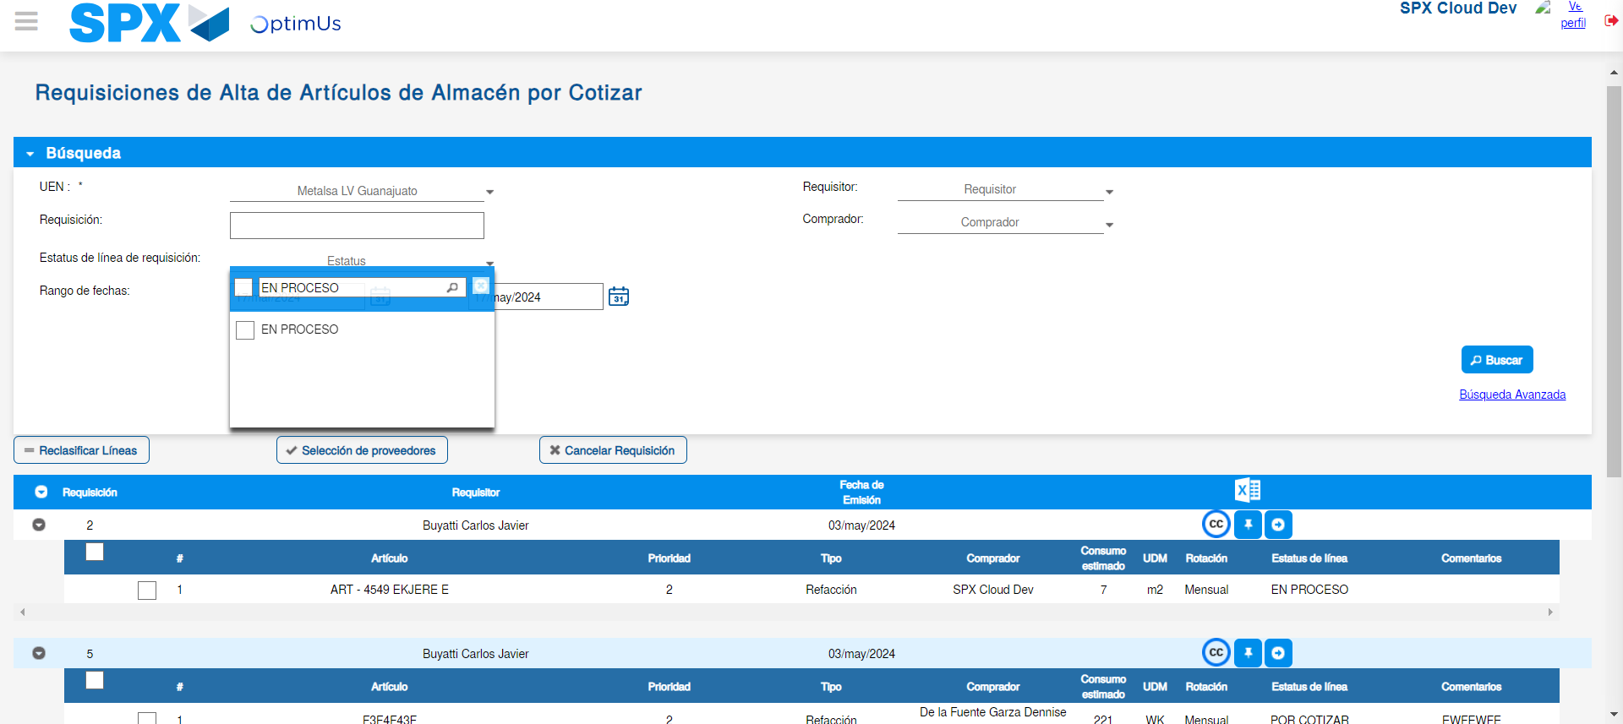Image file-name: QC_Testing-tc001_SPX_Dev5_Validar_Campos_Proceso_Nuevo_Articulos_Almacen-may. 17 2024, 02 18 21 p. m.

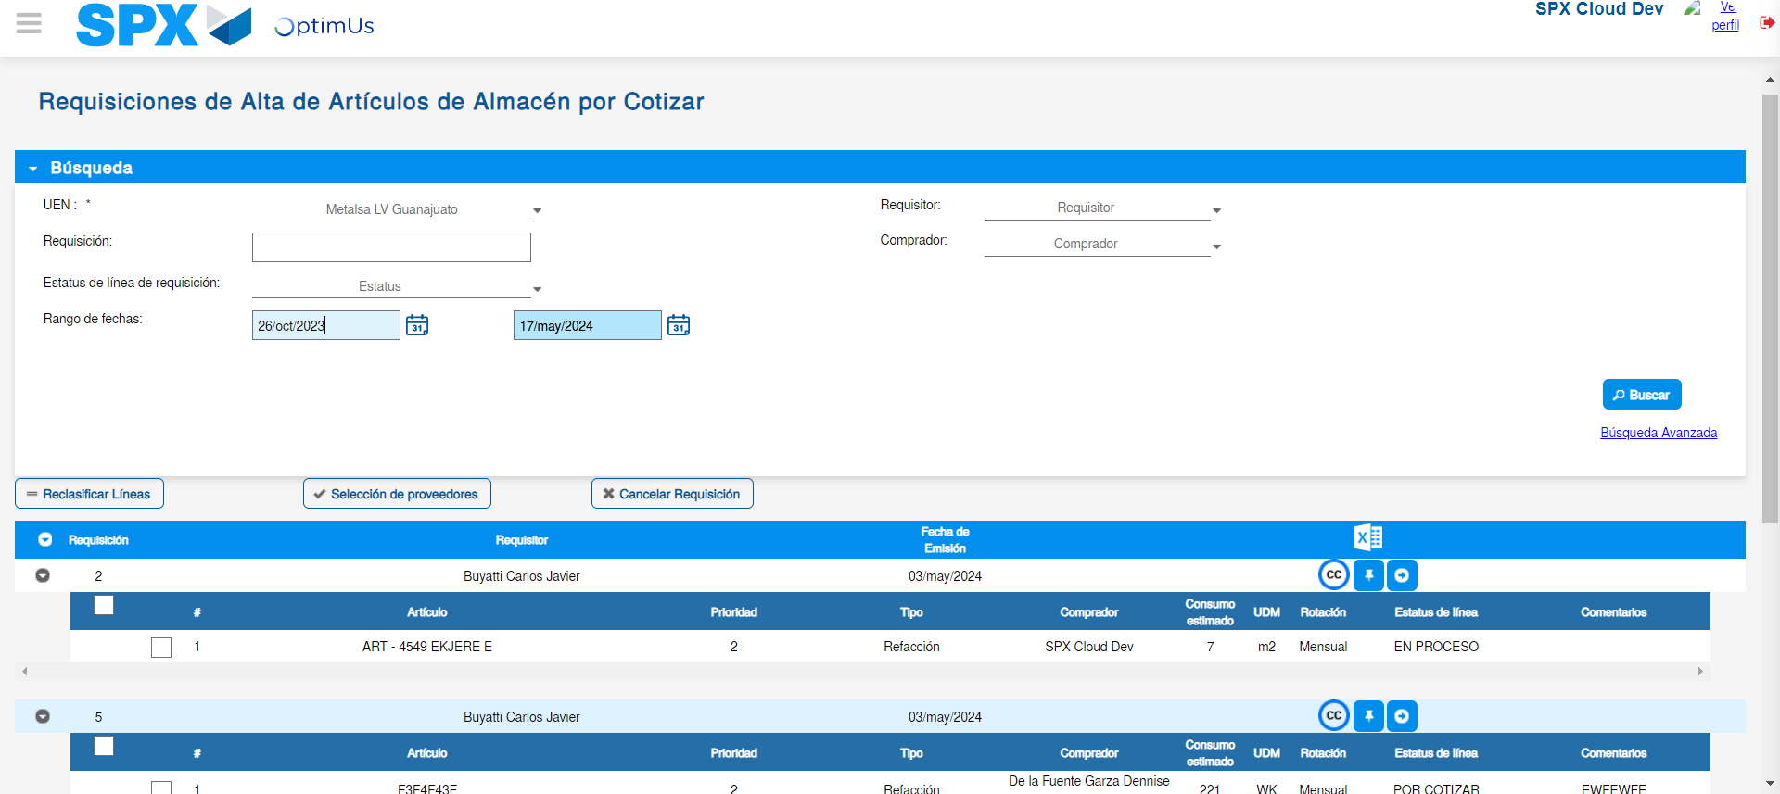Image file-name: QC_Testing-tc001_SPX_Dev5_Validar_Campos_Proceso_Nuevo_Articulos_Almacen-may. 17 2024, 02 18 24 p. m.

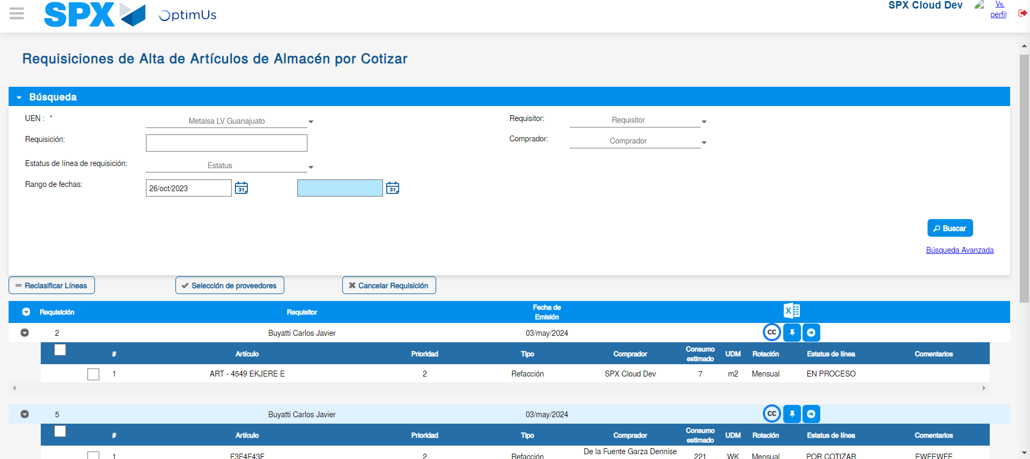Image file-name: QC_Testing-tc001_SPX_Dev5_Validar_Campos_Proceso_Nuevo_Articulos_Almacen-may. 17 2024, 02 18 28 p. m.

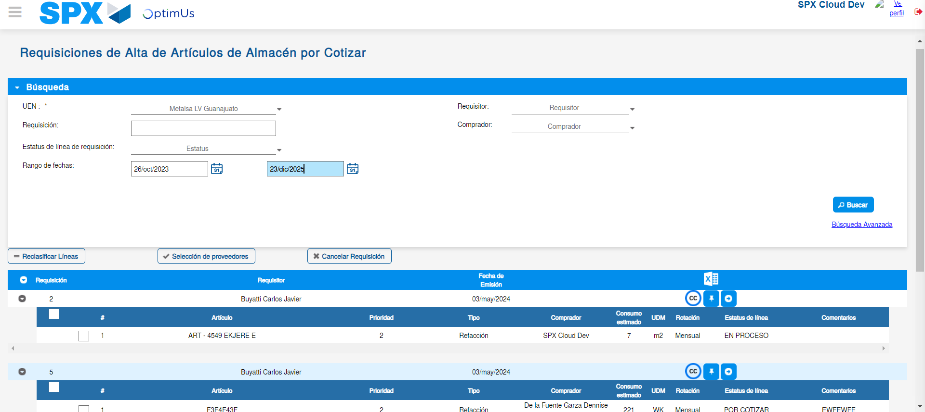Image file-name: QC_Testing-tc001_SPX_Dev5_Validar_Campos_Proceso_Nuevo_Articulos_Almacen-may. 17 2024, 02 18 29 p. m.

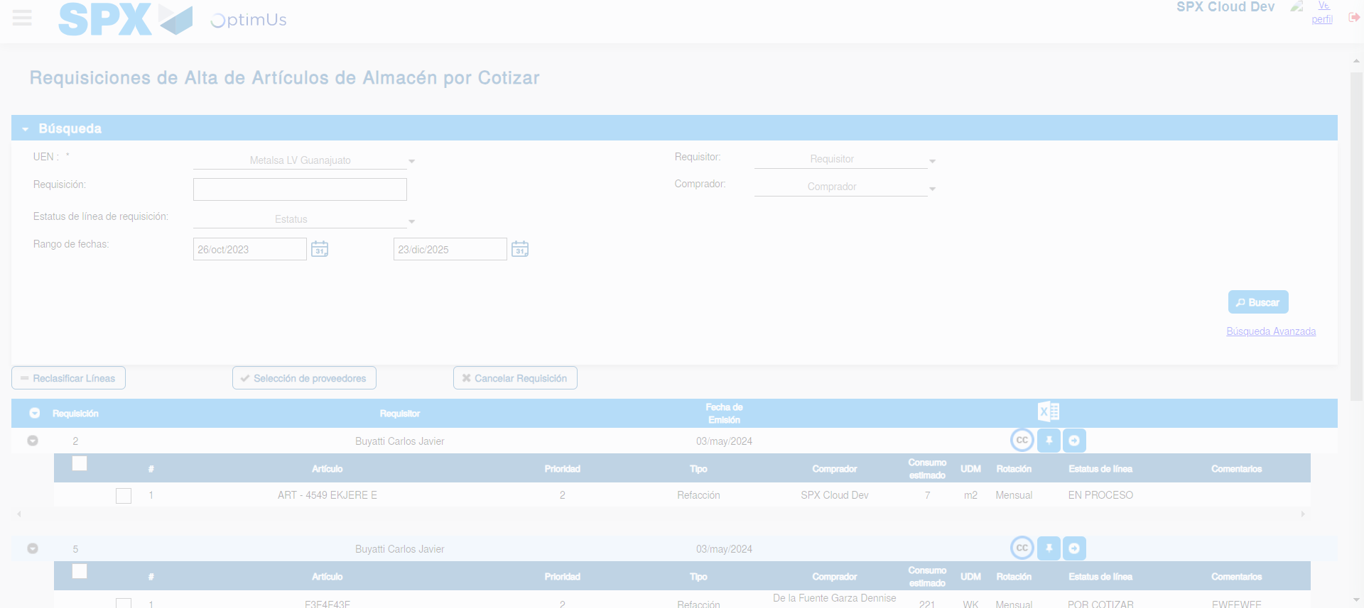Image file-name: QC_Testing-tc001_SPX_Dev5_Validar_Campos_Proceso_Nuevo_Articulos_Almacen-may. 17 2024, 02 18 32 p. m.

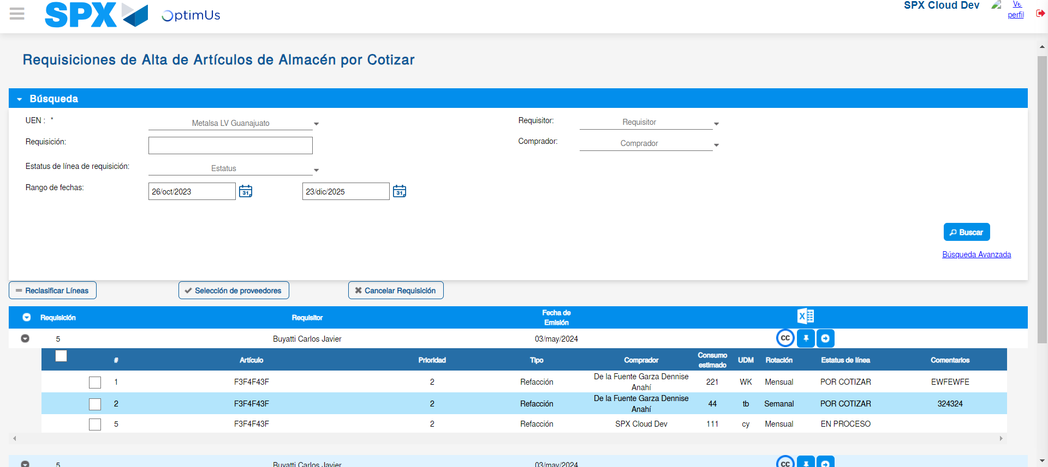Image file-name: QC_Testing-tc001_SPX_Dev5_Validar_Campos_Proceso_Nuevo_Articulos_Almacen-may. 17 2024, 02 18 36 p. m.

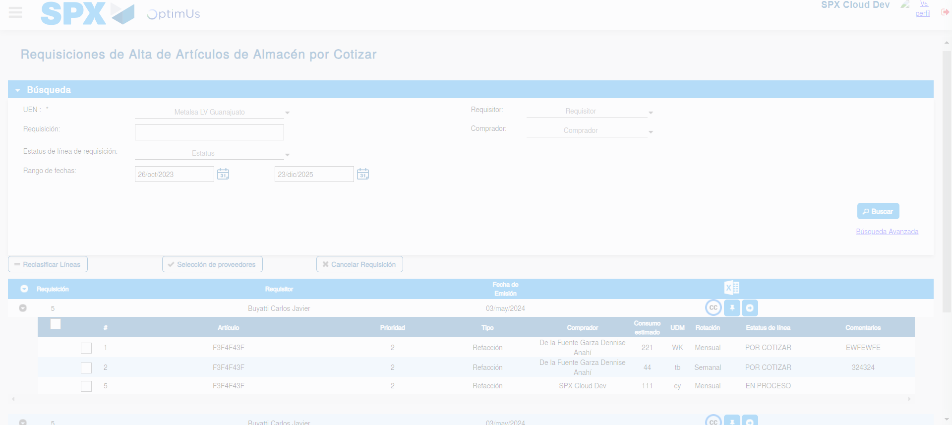Image file-name: QC_Testing-tc001_SPX_Dev5_Validar_Campos_Proceso_Nuevo_Articulos_Almacen-may. 17 2024, 02 18 37 p. m.

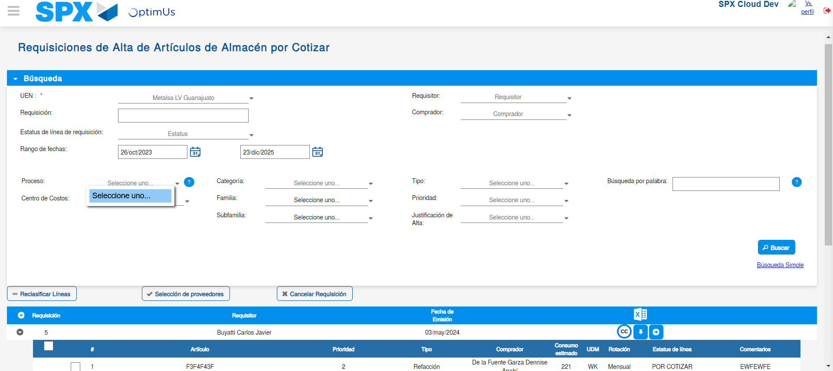Image file-name: QC_Testing-tc001_SPX_Dev5_Validar_Campos_Proceso_Nuevo_Articulos_Almacen-may. 17 2024, 02 18 38 p. m.

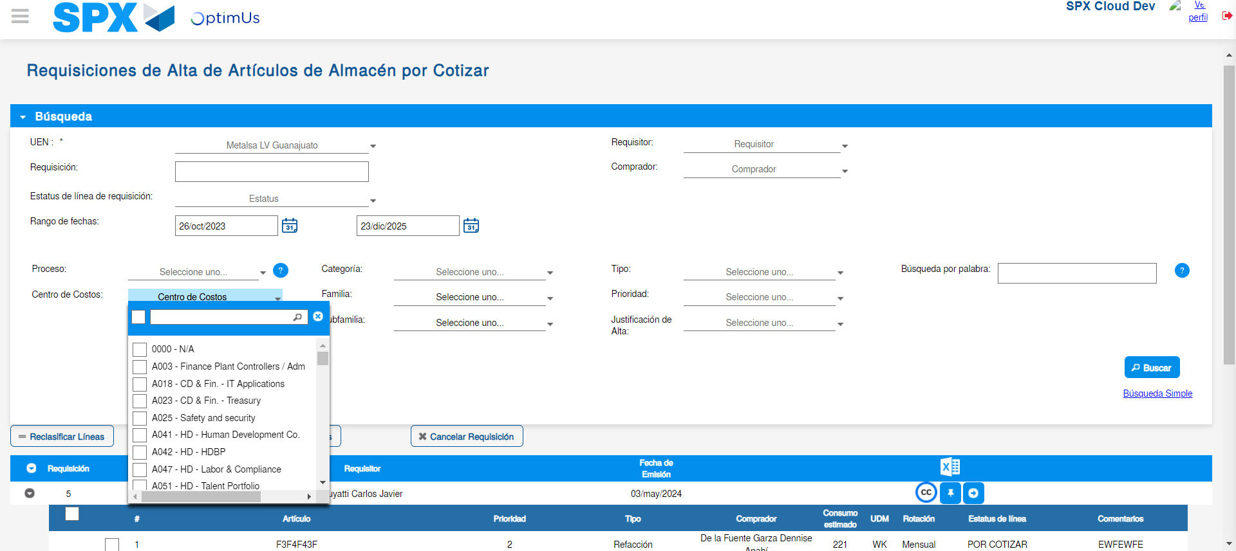Image file-name: QC_Testing-tc001_SPX_Dev5_Validar_Campos_Proceso_Nuevo_Articulos_Almacen-may. 17 2024, 02 18 39 p. m.

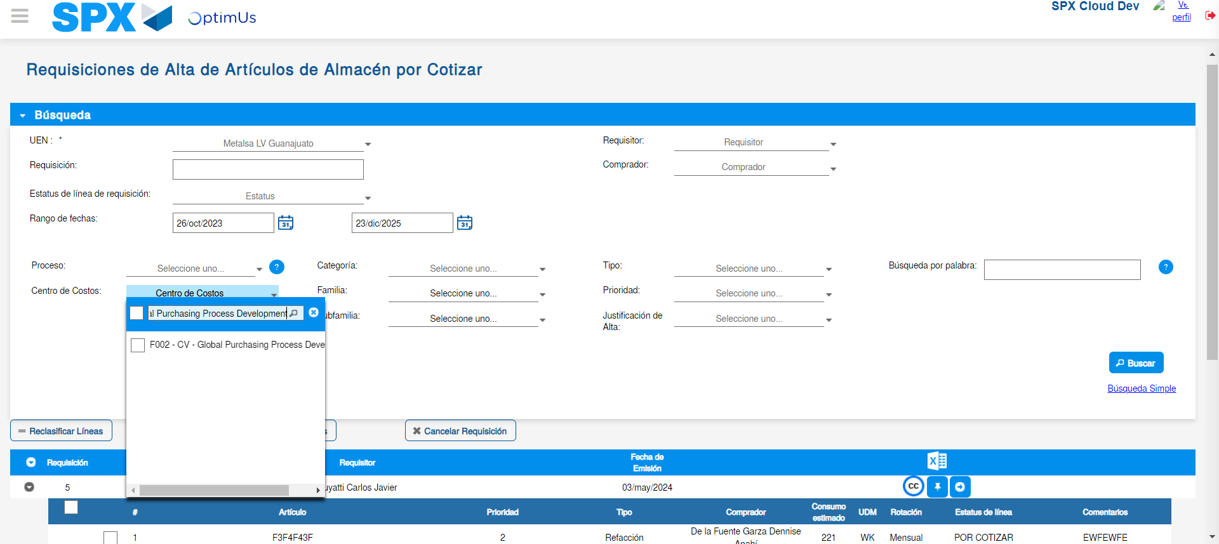Image file-name: QC_Testing-tc001_SPX_Dev5_Validar_Campos_Proceso_Nuevo_Articulos_Almacen-may. 17 2024, 02 18 42 p. m.

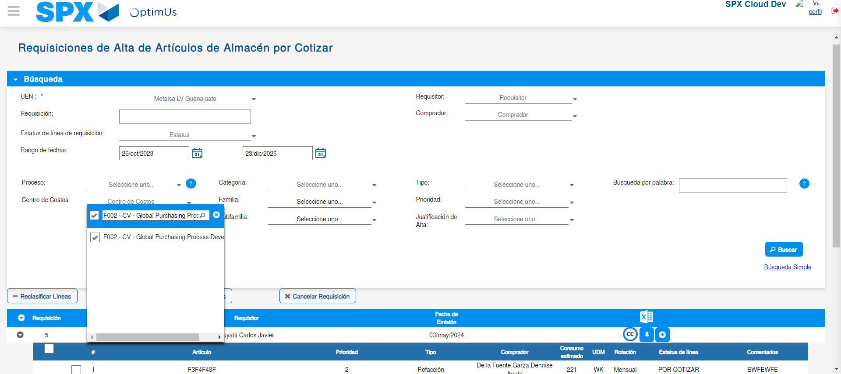Image file-name: QC_Testing-tc001_SPX_Dev5_Validar_Campos_Proceso_Nuevo_Articulos_Almacen-may. 17 2024, 02 18 45 p. m.

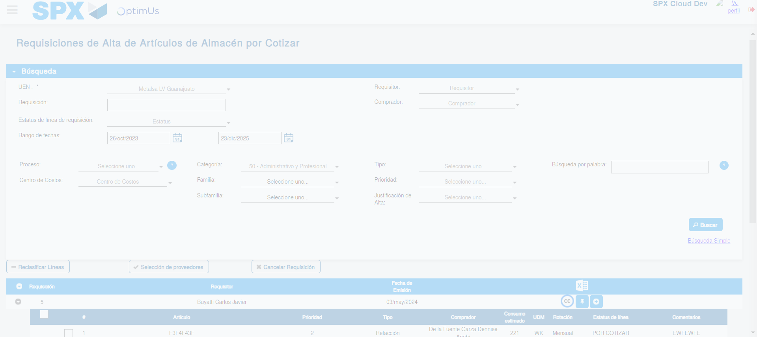Image file-name: QC_Testing-tc001_SPX_Dev5_Validar_Campos_Proceso_Nuevo_Articulos_Almacen-may. 17 2024, 02 18 49 p. m.

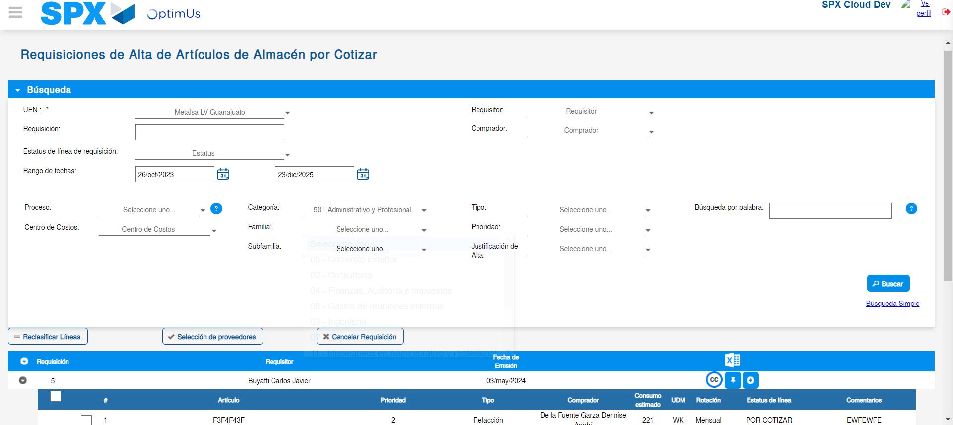Image file-name: QC_Testing-tc001_SPX_Dev5_Validar_Campos_Proceso_Nuevo_Articulos_Almacen-may. 17 2024, 02 18 53 p. m.

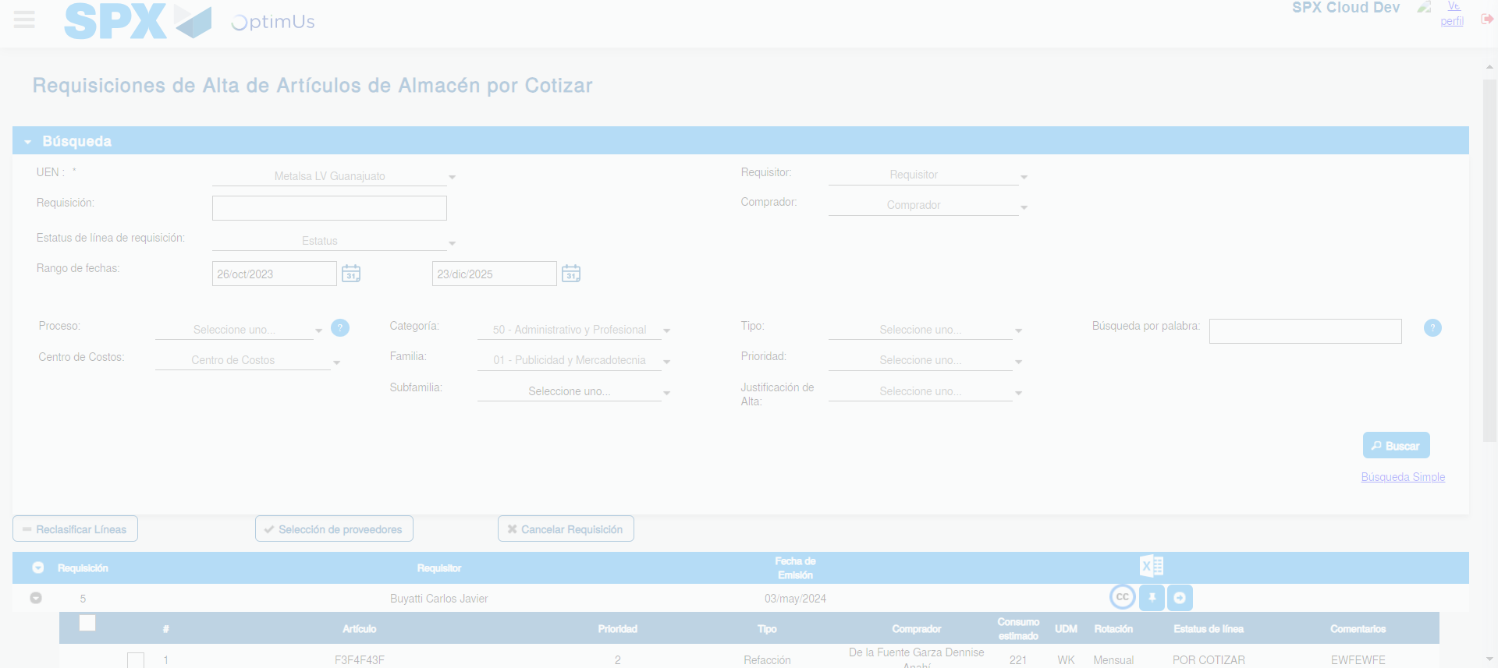Image file-name: QC_Testing-tc001_SPX_Dev5_Validar_Campos_Proceso_Nuevo_Articulos_Almacen-may. 17 2024, 02 18 54 p. m.

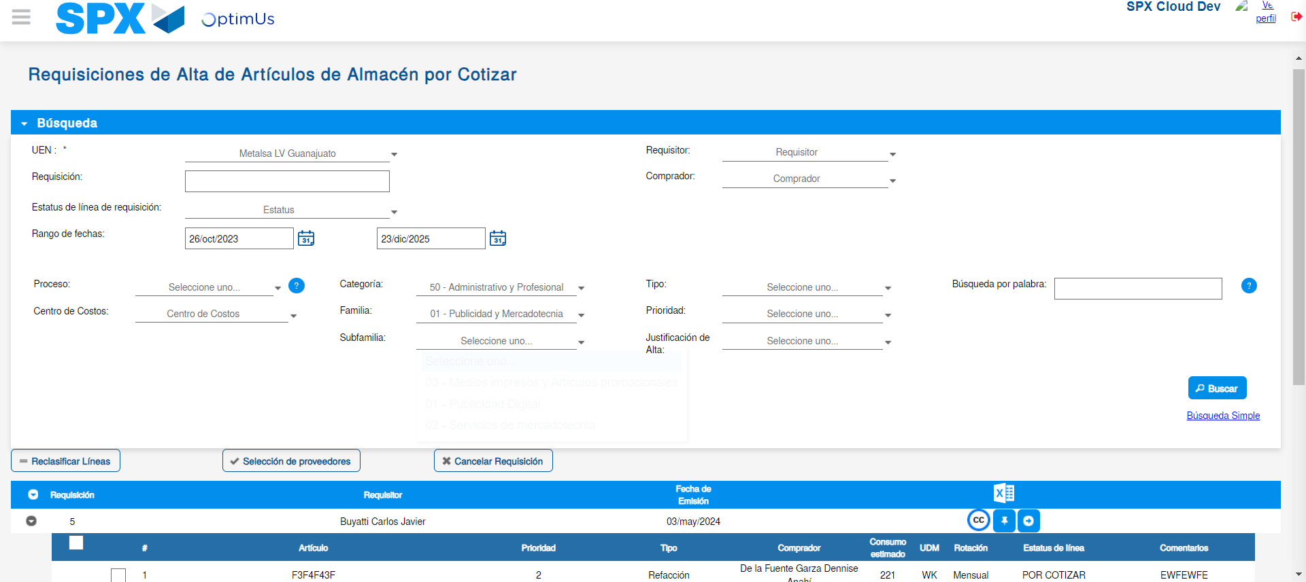Image file-name: QC_Testing-tc001_SPX_Dev5_Validar_Campos_Proceso_Nuevo_Articulos_Almacen-may. 17 2024, 02 18 57 p. m.

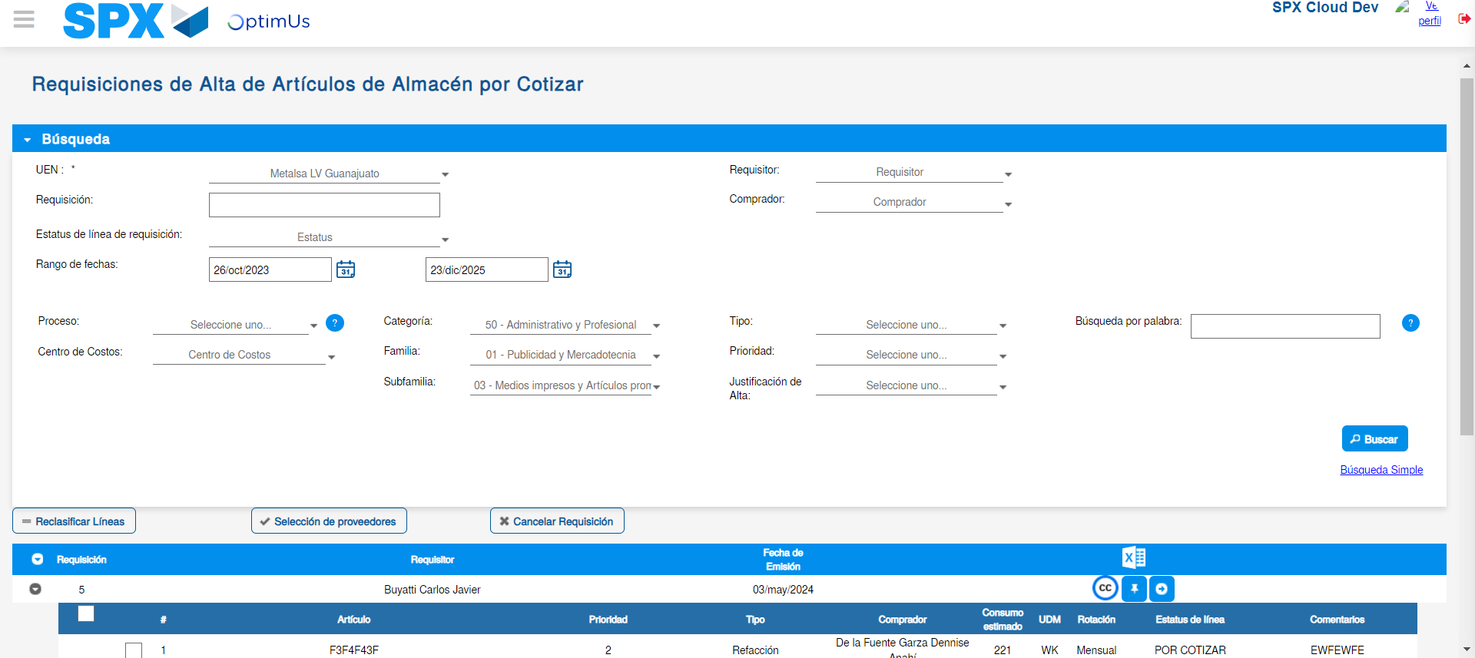Image file-name: QC_Testing-tc001_SPX_Dev5_Validar_Campos_Proceso_Nuevo_Articulos_Almacen-may. 17 2024, 02 18 58 p. m.

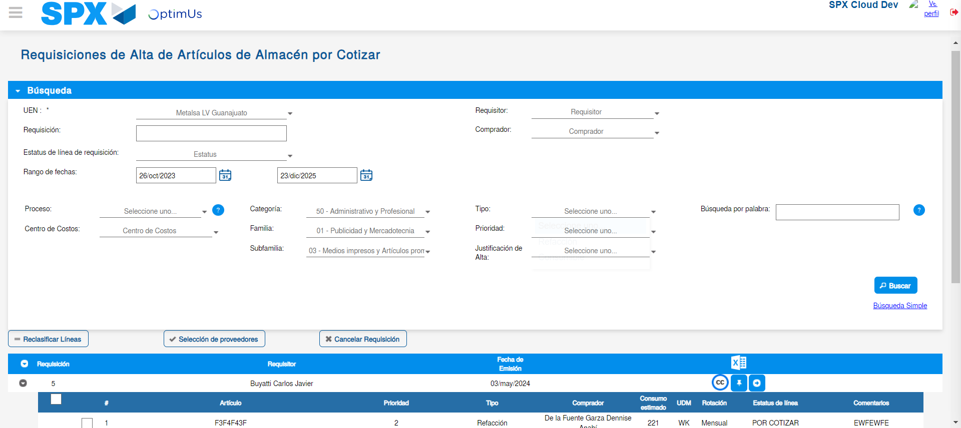Image file-name: QC_Testing-tc001_SPX_Dev5_Validar_Campos_Proceso_Nuevo_Articulos_Almacen-may. 17 2024, 02 19 01 p. m.

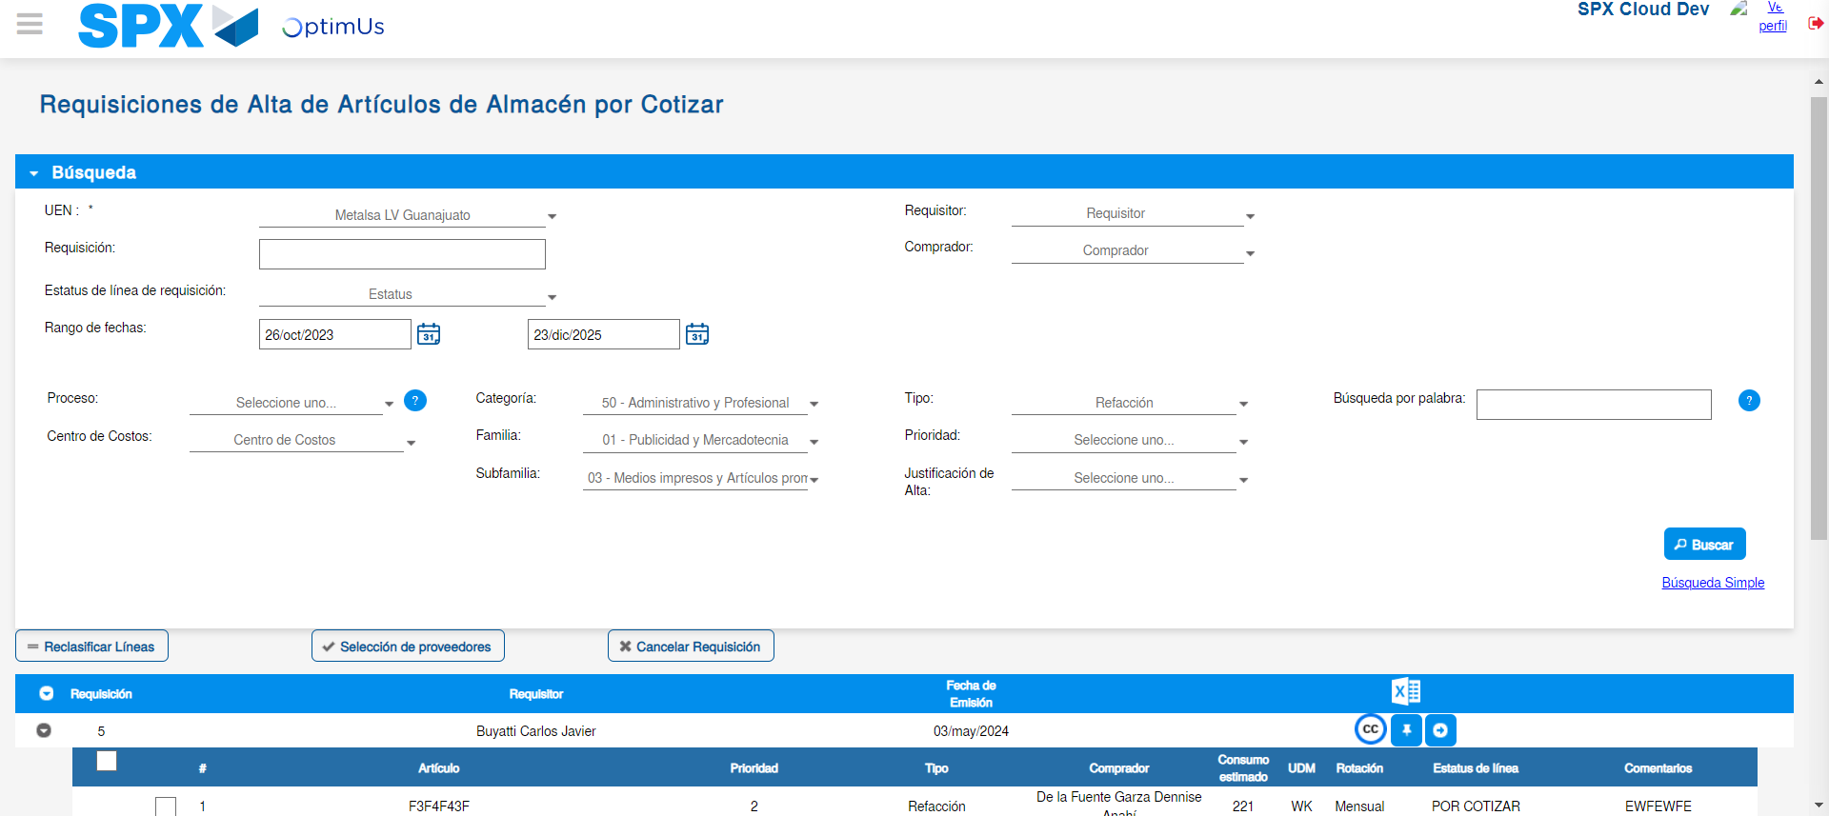Image file-name: QC_Testing-tc001_SPX_Dev5_Validar_Campos_Proceso_Nuevo_Articulos_Almacen-may. 17 2024, 02 19 02 p. m.

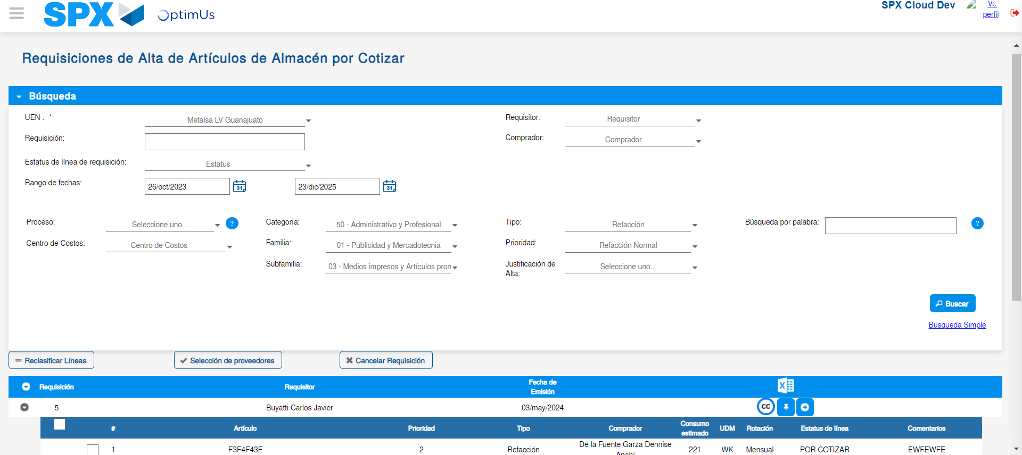Image file-name: QC_Testing-tc001_SPX_Dev5_Validar_Campos_Proceso_Nuevo_Articulos_Almacen-may. 17 2024, 02 19 06 p. m.

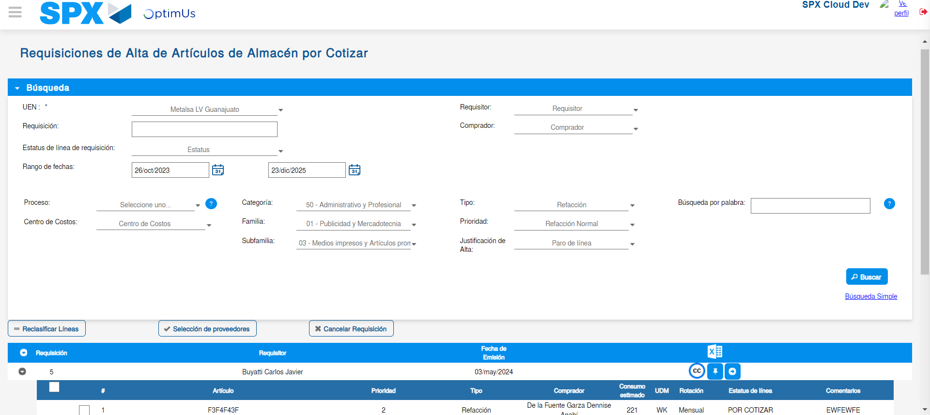Image file-name: QC_Testing-tc001_SPX_Dev5_Validar_Campos_Proceso_Nuevo_Articulos_Almacen-may. 17 2024, 02 19 10 p. m.

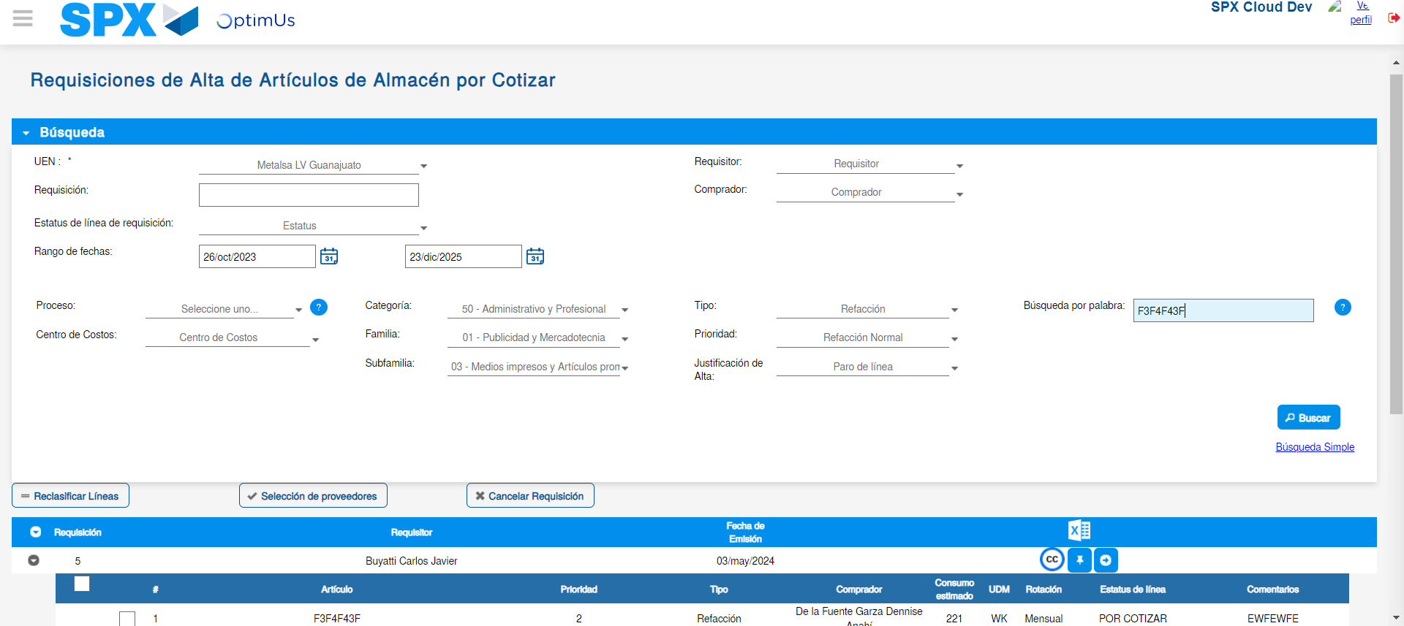Image file-name: QC_Testing-tc001_SPX_Dev5_Validar_Campos_Proceso_Nuevo_Articulos_Almacen-may. 17 2024, 02 19 14 p. m.

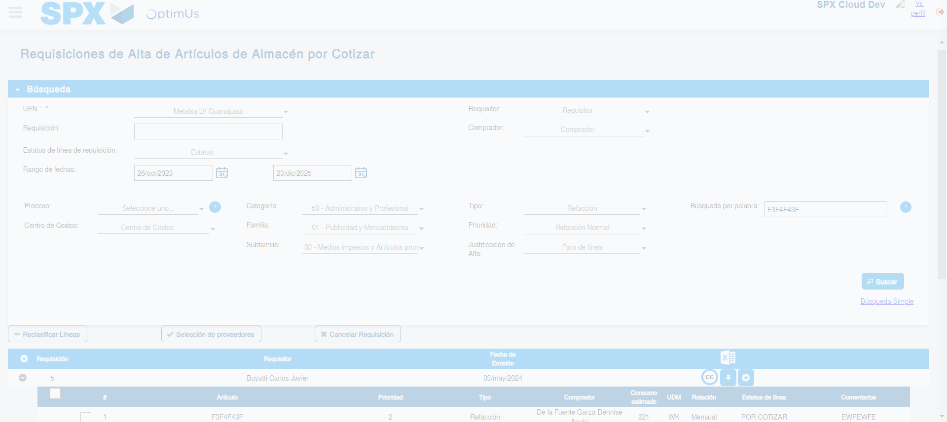Image file-name: QC_Testing-tc001_SPX_Dev5_Validar_Campos_Proceso_Nuevo_Articulos_Almacen-may. 17 2024, 02 19 18 p. m.

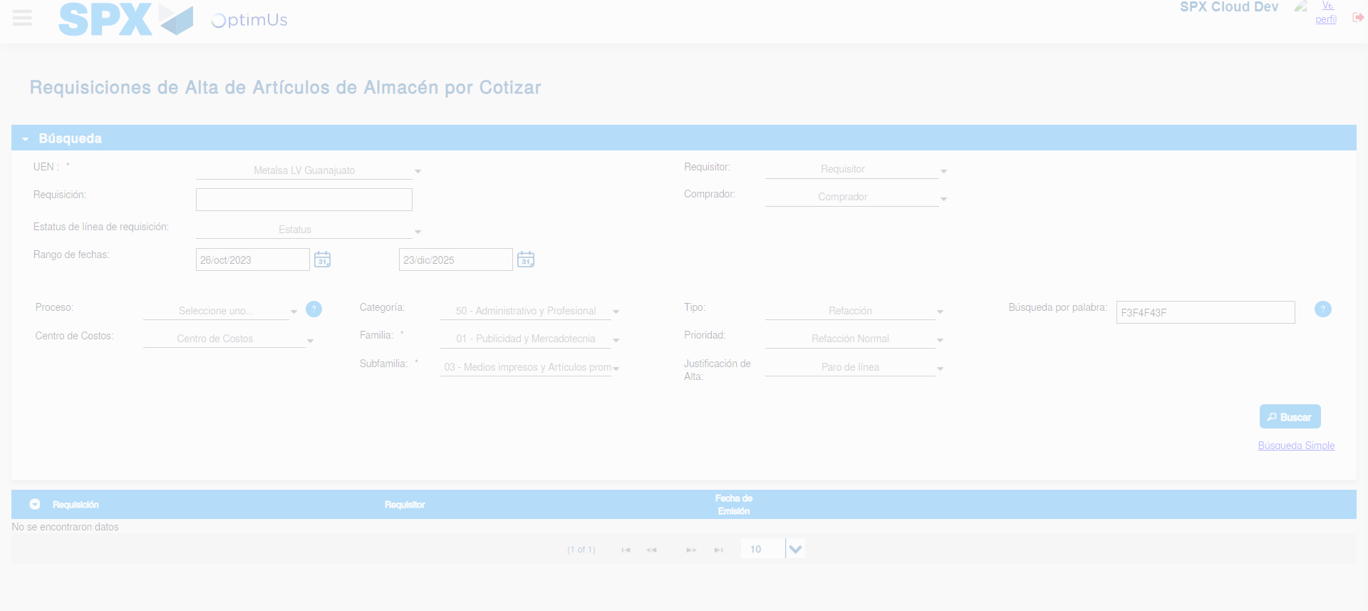Image file-name: QC_Testing-tc001_SPX_Dev5_Validar_Campos_Proceso_Nuevo_Articulos_Almacen-may. 17 2024, 02 19 21 p. m.

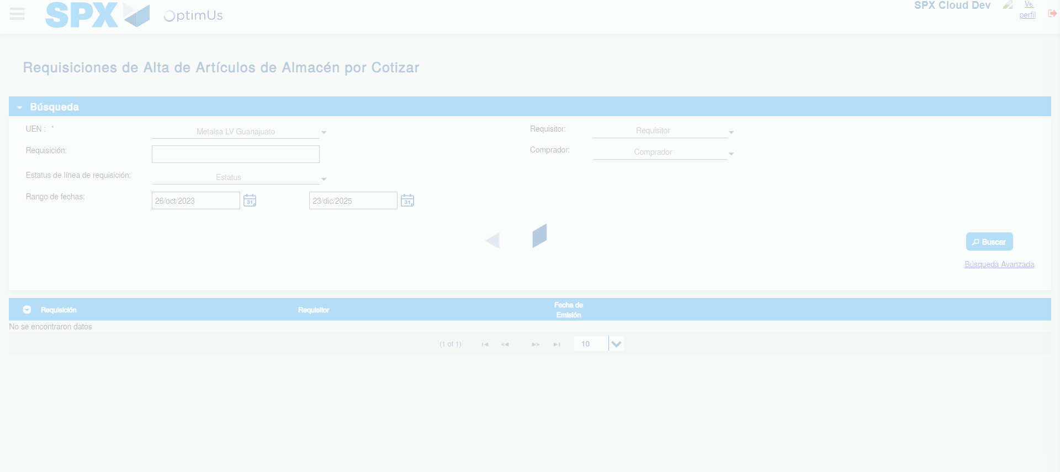Image file-name: QC_Testing-tc001_SPX_Dev5_Validar_Campos_Proceso_Nuevo_Articulos_Almacen-may. 17 2024, 02 19 22 p. m.

